

vibration platform

INSTRUCTION MANUAL
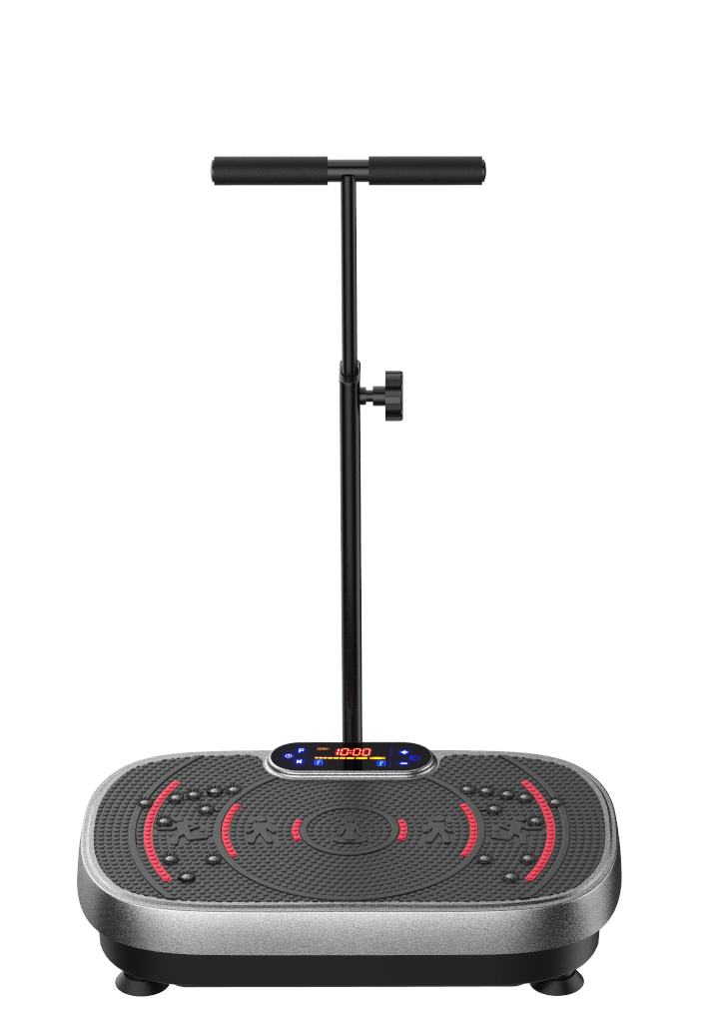

IMPORTANT, RETAIN FOR FUTURE REFERENCE: READ CAREFULLY



safety Information 02
contents …04
product overview 05
Assembly Instructions… 06
control panel 07
Remote control …08
operating Instructions 09
vibration Benefits… 1 1
preparation …12
How to use - Exercise cu ide 13
Troubleshooting …19
1 -year Limited warranty ·20

 | 1 1 0V
 | 200 watts
 | 20.87 in x 15.75 in x 37.4 in
 | 24.25 bs
 | 330 Ibs

please read and understand this entire manual before attempting to assemble, operate, or install the product.

WARNIN: To reduce the risk of burns,fire, electric shock, serious injury or death, or damage to the product or property:
ELECTRICAL SAFETY

, use only the included power cable and ensure it matches the product's specified voltage. Do not use third-party cables or outlets that do not meet the listed specifications-doing so may cause fire or explosion.
. plug the power cable directly into a properly grounded electrical outlet.
Do not use an extension cord or power strip.
· keep away from all flammable or explosive materials, including: open flames, heat sources, chemicals, high ambient temperatures or direct sunlight.
· Avoid high-moisture environments, such as: Bathrooms, damp basements, outdoor areas, near pools or hot tubs.
· Never bend , twist, pull , or tie the power cable.
Always unplug by gripping the plug, not the cord.
· Do not attempt to modify, open, or repair the machinet. This product contains no user-serviceable parts.
· Never operate ifany component appears damaged, frayed, or tampered with.
· Before each use, inspect the: cable, plug and connector, wall outlet, and device.
· Discontinue use and contact customer support immediately if: · Any part appears damaged or worn
· You notice exposed wires
· The unit has been exposed to water
· You detect unusual smells, sounds, or overheating · Do not use the product during electrical storms.
 DlscLAMER
· The health benefits suggested or implied in this user manual , our other product literature,
and website are notcertified or endorsed byany regulatory authority or medical institute.
· The use ofthisvibration machine is entirelyatthe user's discretion. please read all instructions and safety information carefully before using this product. we assume no responsibilityfor
personal injury or propertydamage sustained byor through using this product.
PRECAUTINS

· It is the responsibility of the owner to ensure that all users of the productare adeauately informed ofall warnings and precautions.
, use the product only as instructed in this manual.
· check the machine, power cord , and remote for damage or loosened screws prior to each use. Tighten any loosened screws before use. Do not use ifdamaged , faulty, or defective.
keep children and pets away from the machine at all times. Never allow children to play with or on the machine.
· Adults with diminished mental or physical capacity or balance disorders may only use the Machine while supervised by a responsible adult.
· The machineshould not be used by persons weighing more than 330 lbs.
· Never allow more than one person on the machineat a time.
place the machine on a level , non-slip surface, with at least five feet ofclearance on all sides ofthe machine
02

Do not place the machineon any surface that blocks air openings. To protect the floor or carpet from damage, place a non-slip rug or exercise mat under the
machine.
 EXERCSE SAFETY
consult with a medical professional before beginning a new exercise program to determine your appropriate fitness intensity and duration.
people with the following conditions must get approval from a physician before
using the machine: anyone who is or may be pregnant, or has recently given birth;
people who experience dizziness or balance disorders or are taking drugs that affect balance; people with implants such as pacemakers, intrauterine devices, joint
implants, chest stents, or other medical implants; people with open wounds, tumors, heart or vascular disease, blood circulation disorders, chronic hypertension,
osteoporosis, rheumatoid arthritis, acutejoint disease, thrombosis, arrhythmia, severe diabetes, epilepsy, or acute migraines; people with spinal injuries, fractures, herniated discs, or ankylosing or cervical spondylitis.
stop exercising immediately and contact your doctor ifyou feel tired, dizzy, or nauseous, or ifyou experience pain, difficulty breathing, or abnormal heart rate. · Never place your head or upper body directly on the machine.
· Do not perform other activities while using, as this could cause accidents or injury. · Do not get on or offthe machine until it is fully stopped. Do notjump on the
machine.
· Do not use more than 20 minutes per day. prolonged or overly-intense exercise can be damaging to your health.
· Always wear appropriate clothing and athletic shoes. Do not use while wearing socks or slippers as this may cause slipping. Do not wearjewelry or belts.
· The Machine is intended for in-home use only. Do not use the Machine in any commercial , rental , or institutional setting.
CLEANINC, STORACE & MAINTENANCE
 DANGER: Always unplug the power cord immediately after use, before cleaning, moving, storing, or performing any maintenance procedures described in this
manual. Allow to cool before cleaning, moving, storing, or doing maintenance.
use a slightly damp cloth or soft towel to wipe away dirt or moisture. Do not use abrasive, solvent, or chemical cleaners or harsh detergents.
store in a well-ventilated area free ofdust, with low humidlity and out ofdirect sunlight.
, when storing for a long time, remove the batteries from the remote control and cover the machine to keep out dustand dirt
Inspect and tighten all external screws periodically. Never remove the motor hood unless instructed to do so byan authorized service representative. servicing other than the procedures in this manual should be performed byan authorized service representative only.
Never insert or drop any object into any opening.

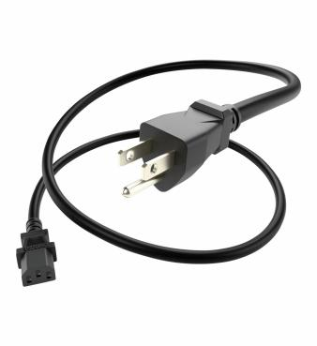
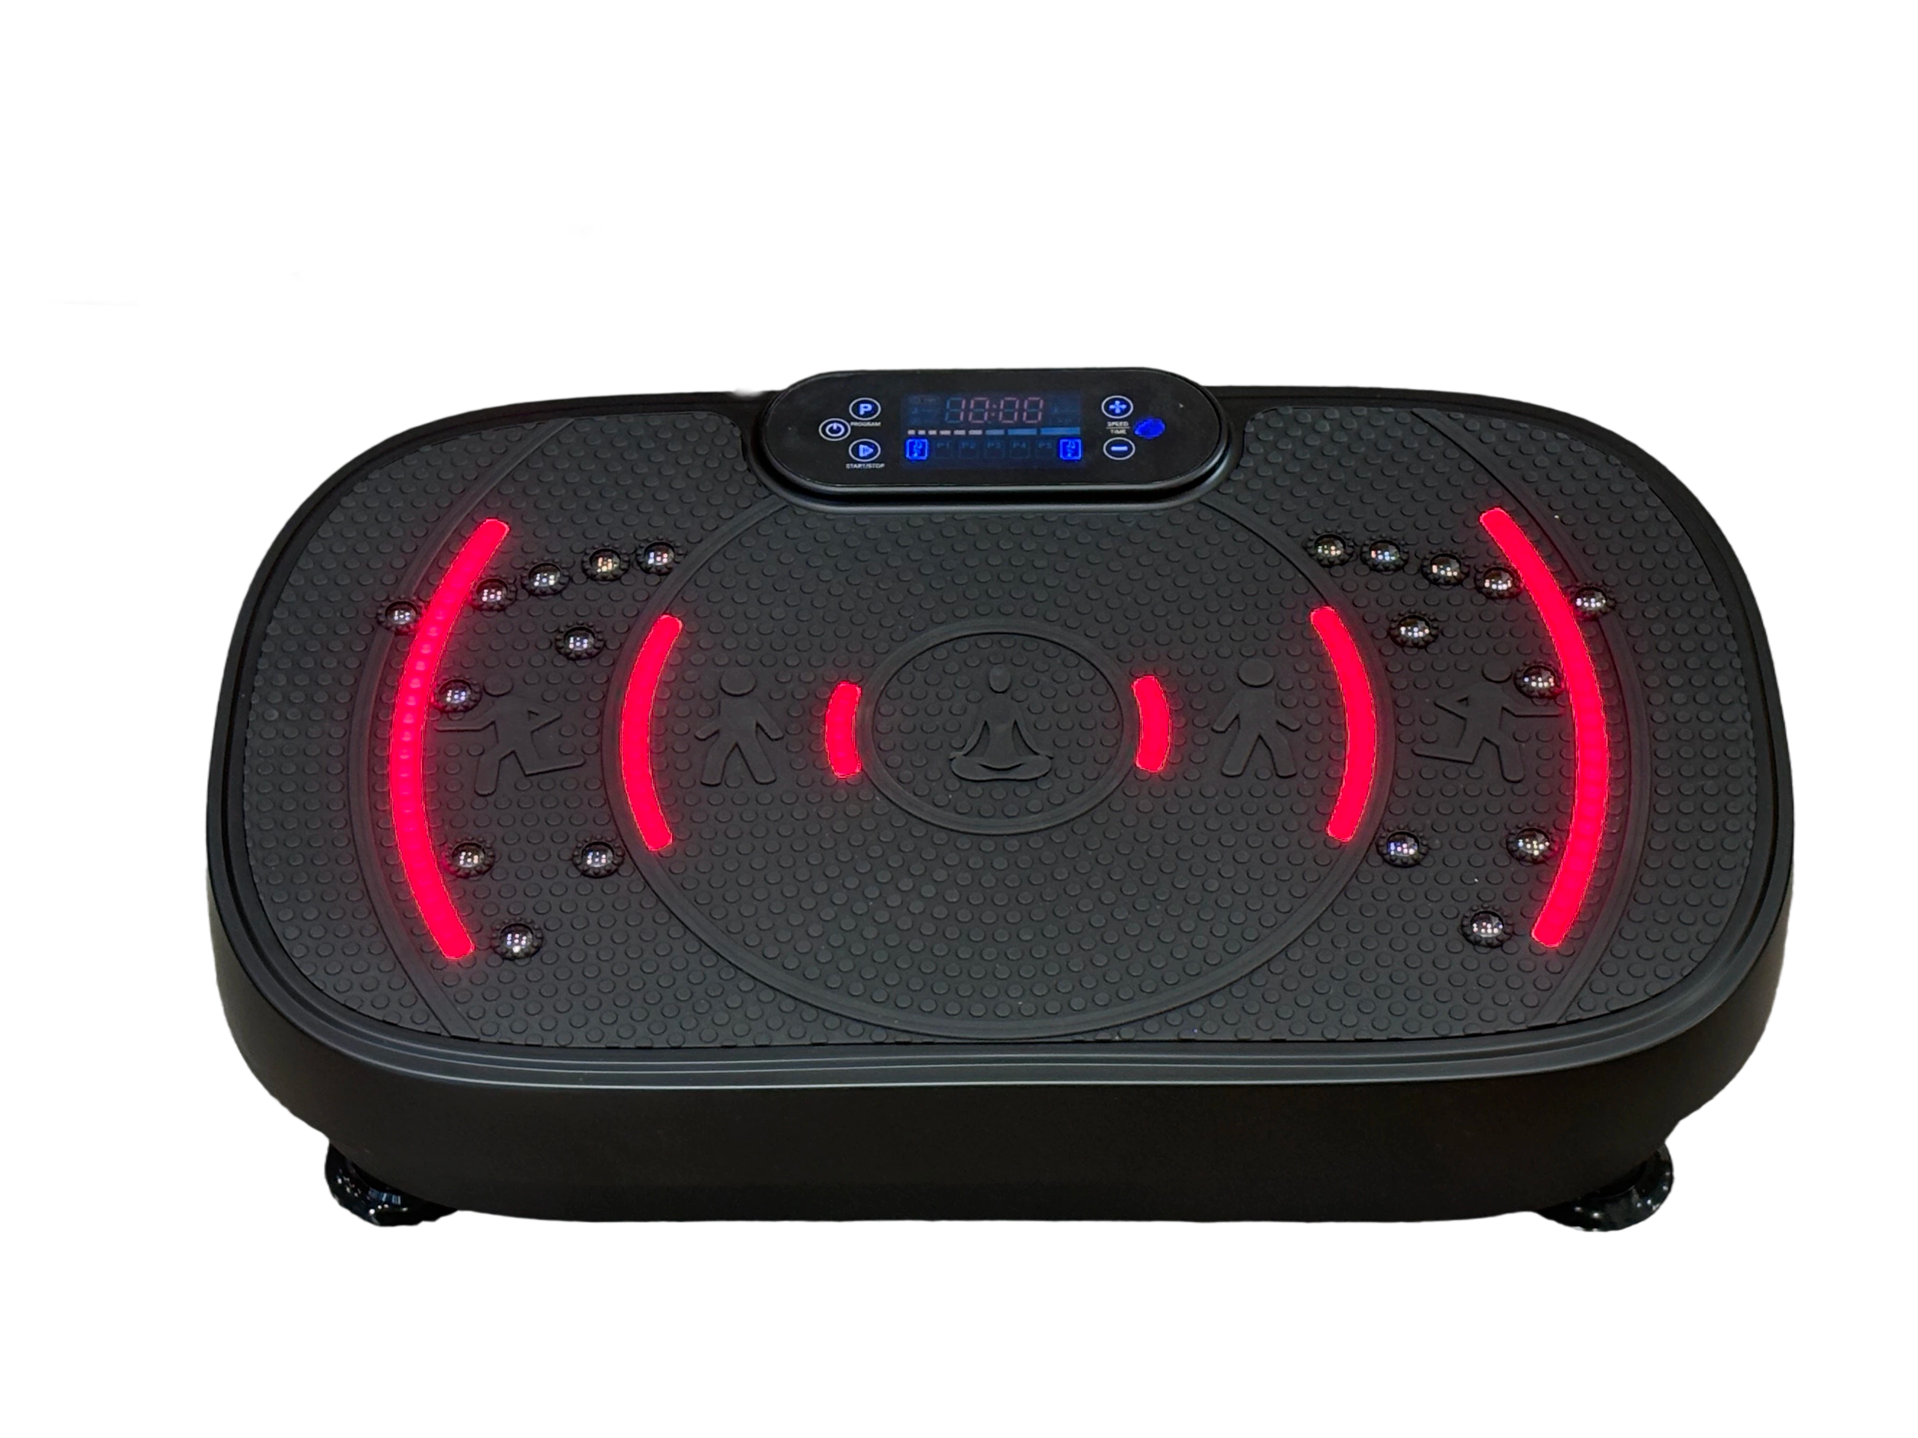
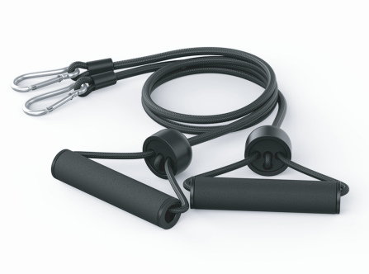
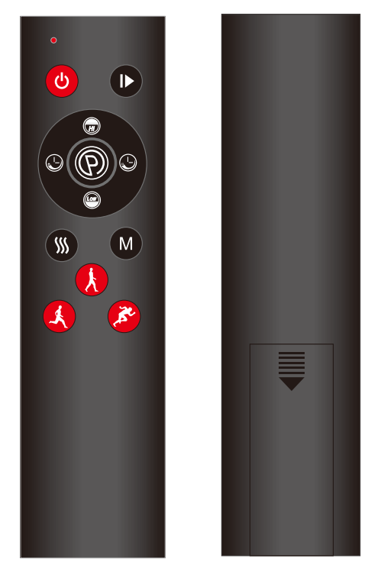 | 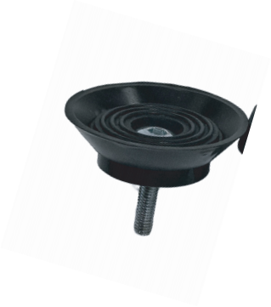  5x suction Cup (pre-installed*4) |  |  | wrench  & Hex Tool  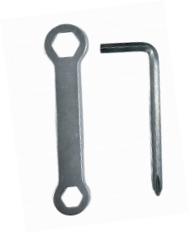 | 1 x Height  Adjustment
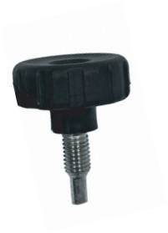
knob
Handlebar  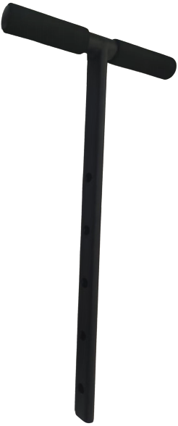 |  | upper post  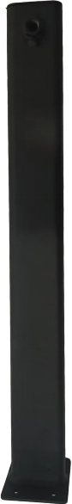 | 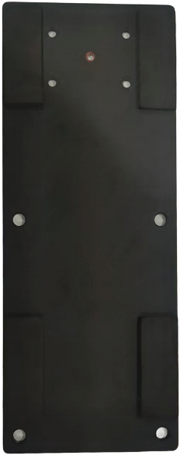  Baseplate 4x Flathead screws  2  4x screws & cap Nuts  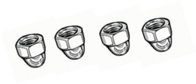

ASSEMBLY NOTES
· Assemble the machine on a flat, sturdy fl oor.
, Ensure the space is free of obstructions
* Resistance bands are attached on the underside of the machine. During assembly you can rotate the bars outward and attach the included resis- tance bands.


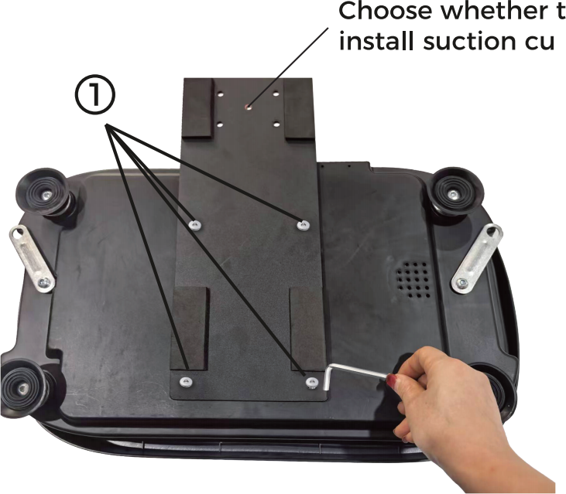
step 1 :
Align the base plate to the under
side of the platform unit and secure with hex tool &4x silver flathead
screws ·
Includes 5 suction Cup feet-4
pre-installed for stability, plus 1 extra for added support when operating
the unit without the base plate and handlebars.

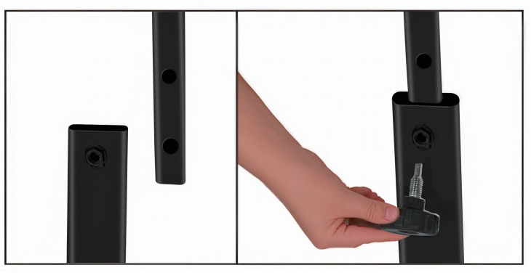

step 3:
Attach the top post ane handle-
bars to lower post with the height adjustment knob.

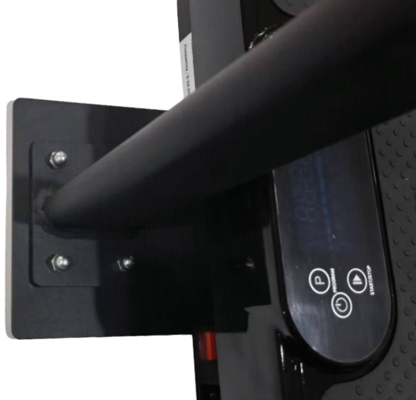
step 2:
secure the lower post to the
base plate with 4x siver screws 2 and 4x cap nuts. Tighten with tool.

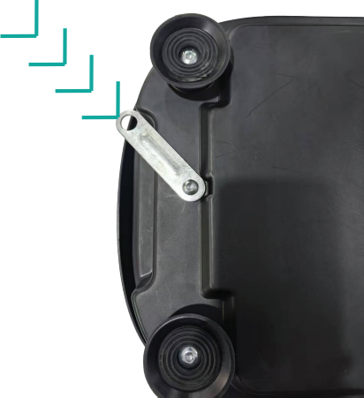

step 4:
Located on the underside of the machine, rotate the metal bars
outward extending past the vibra- tion plate. clip a resistance band to the hole on each side.

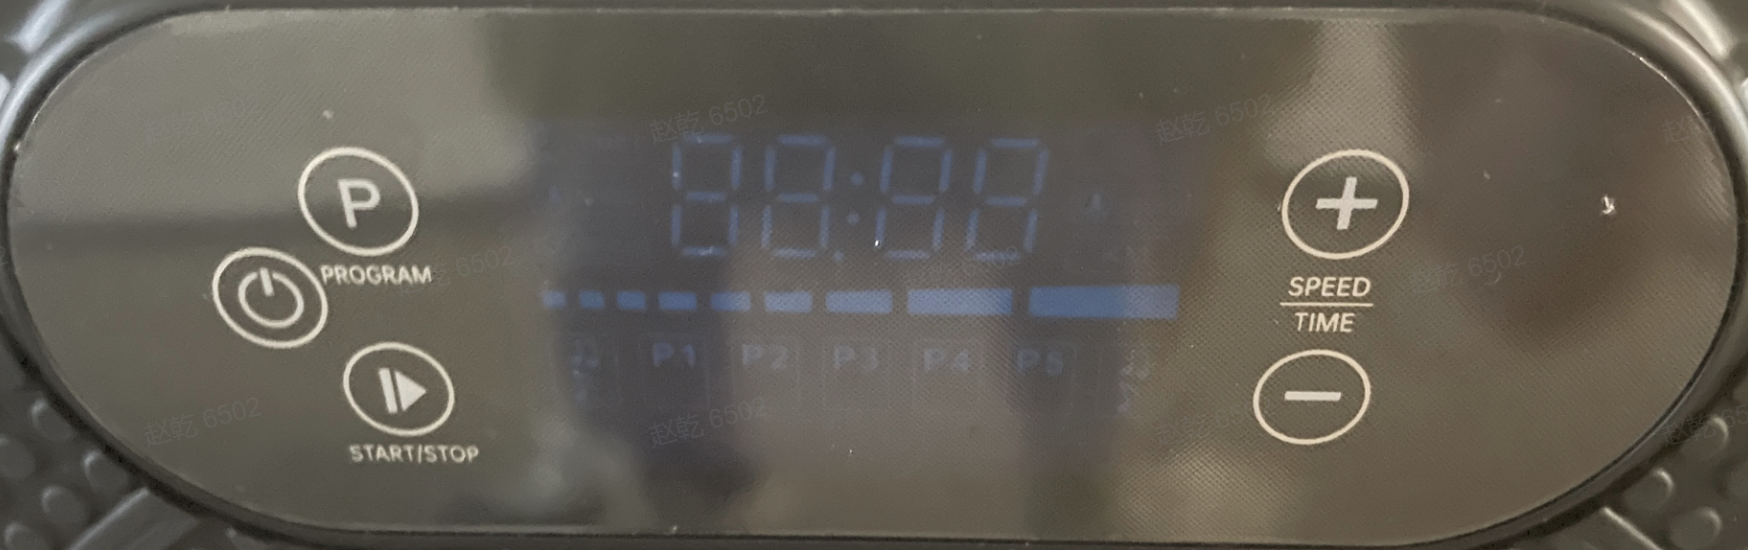

 | 
1 . power Button | Power On — Disable Red Light and Heating — Power Off
2. program Button | cycles between manual and pre-set auto vibration modes P1 -P5
3. LED Display | Displays off timer countdown or vibration speed level.
4. speed/Time - Button | Decreases speed levels (1 -120) or OFF-timer in manual mode.
5. Mode Indicator | Indicates Auto Mode program (p to P5)
6. speed/Time + Button | Increases speed levels (1 -120) or OFF-timer in manual mode.

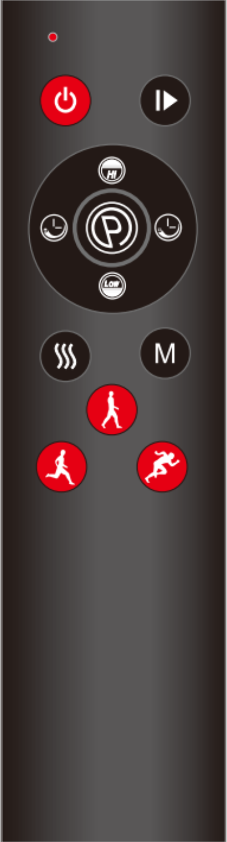

2
1

4
3

6
5

7

8
9
10

12
11

 | 
1 . power Button | powers the machine ON/OFF(standby mode)
2. pause Button | press to to stop, press again to begin vibration.
3.speed + Button | Increases speed levels (1 -120) in manual mode.
4. program Button | cycles between manual and pre-set auto vibration modes P1 -P5
5. Time - Button | Decreases OFF-Timer in manual mode
6. Time + Button | Increases OFF-Timer in manual mde
7. speed - Button | Decreases speed levels (1 -120) in manual mode.
8. Red Light Button | Turn Red Light and Heating On/Off
- Light Button | Turn lights on/off
- Walking Button | Walking Mode
- Jogging Button | Jogging Mode
12. Sprint Button | Sprint Mode

ΔWARNIN
o INGESTioN HAZARD: This product contains a button cellor coin battery.  DEATH Or serious injury can occur if ingested.  A Swallowed button cell or coin battery can causelnternal chemical Burns in as little as2 hours.  KEEP new and used batteries OUT OF REACH Of cHILDREN.  . seek immediate medical attention ifa battery is suspected to be swallowed or inserted inside any part of the body. | 

 control panel overview

· power switch
press to turn the machine on or off.

. start Button
press to begin operation.
· Automatic programs (p1 -P5)
The device includes 5 pre-set automatic programs: P1 , P2, P3 , up to P5 .
These offer a variety of preset workout routines for different fitness needs.
· speed + / - Buttons
use these to increase or decrease speed levels (1 - 120) when using manual mode.
Note: speed cannot be adjusted during automatic programs.
· Time + / - Buttons
use these to increase or decrease workout duration in manual mode. Note: Time cannot be adjusted during automatic programs.
Remote control operation
· The effective range for the remote control is 2 . 5 meters (8 . 2 ft).
· Ensure the remote's infrared light is pointed directly at the infrared receiver window on the device.
 Auto program speed cuide
Each program is designed with 4 speed stages (s1 -s4) that run in
seuence during your session. These stages automatically vary the vibra - tion intensity to keep your workout dynamic, effective, and user-friendly.
How It works:
Each Auto program (p1 -P5) progresses through four speed levels (s1 → S2 → S3 → S4). You cannot manually adjust the speed during these programs.
The system automatically shifts the vibration speed at timed intervals to simulate interval training or varied workout intensity.
To start an automatic program:
1 . Ensure the machine is in standby Mode by pressing the stop button
2 . press your desired program button (p1 -P5).
3 . If you wish to change to a different program , press the stop button

speed Breakdown by program:


 | 20 60 40 80
P2 | 30 70 50 90
P3
P4 | 50 90 70 1 1 0
P5 | 60 1 00 80 1 20
Each program automatically cycles through all four stages during your session for a well -rounded vibration workout.
 standing positions : where you stand on the vibration platform affects how challenging the vibrations feel on your body·
· stand with your feet close together for an "easy" workout.
, stand with your feet wider apart for a " medium " or " intense" workout.




EXERCISE TIPS
, start with 5- 1 0 minute sessins and increase gradually.
, Cnsistent use supprts lng-term fitness results.
, Beginners: stand with feet clse tgether fr lwer intensity. . wear athletic shes and Cmfy wrkut clthes.
, Bareft use increases intensity; n sCks r slippers.
, Remve jewelry, ISe clthing , and anything in pckets.
· use smth , CntrIled mvements.
· place a twel r mat n the platfrm when using hands r lying dwn. · wait at least 80 minutes after eating befre using.

 |  |  |  | 
reat fr starting ut. |  | perfect fr peple with |  | creat fr increased
 |  | arthritis and fibrmyalgia. |  | intensity.
 Detxificatin |  | Jint |  |  Fat loss
 Increased bne |  | maintenance |  |  Muscle grwth
density |  |  Imprved |  |  Highly increased
 Imprved balance |  | pstural Cntrl |  | bne density
 Lymphatic drainage |  |  Fat loss |  |  PWer
 Imprved |  |  Increased bne density |  | accum ulatin
pstural Cntrl |  |  Imprved balance |  |  HCH release
TO ET THE BEST RESULTS, ALTERNATE BETWEEN PROGRAMS
keep yur bdy guessing. we tend t adapt, s we want t Cntinue eliciting
change in ur bdies. Each level has its wn set f benefits; hwever, we recm mend yu start ut at the first level , P1 , and Wrkyur way up.

MANUAL MODE
In manual mde, vibratin speeds Crrespnd t the settings abve:

LW Settings Medium settings High setting
(1 - 43) (44 - 96) (97- 1 20)

SAFETY TIPS
· D nt get n r ff the Machine until it is Cmpletely stpped.
· use the remte CntrI t adjust the Wrkut nce exercise has begun.
using the CntrI Panel while the machine is mving CUld cause an accident r injury.
· Always stand n the machine with yur back straight, yur knees slightly bent, and yur heels slightly lifted.
· D nt use the machine with straight legs r arms, as the vibratins are directed t yur bnes and brain , which can be dangerus fr yur health.

Always slightly bend yur legs and arms.
. If yu feel vi bratins in yur eyes, VCal Crds, r ther parts fyur head , yu are nt standing n the machine Crrectly and shuld shiftyur psitin
immediately.
· Never place yur head r upper bdy directly n the machine.
· Never jump n r jump ff the machine.
· Never attempt t turn arund n the machine while it is in mtin. D nt quickly lean back r change psitin while the machine is in mtin.
· stP exercising immediately and Cntact yur dctr ifyu feel tired , dizzy, r nauseus, r ifyu experience pain , difficulty breathing , r abnrmal heart rate. · Never perfrm ther activities while using the machine as this CUld cause
accidents r injury.
· D nt use fr mre than 20 minutes per day. prnged r ver-intense exercise can be damaging t yur health.
· Make sure yur bdy is used t the vibratins befre yu sit n the machine · · · D nt use after drinking alchr taking medicatin that CUld affect yur balance r make yu sleepy.

SETUP TIPS
, place the Machine n a level , nn-slip flr. YU may put an exercise mat under the machine t prtect carpet r ther flring , and/r reduce nise.
, set up the Machine up in an area with at least 5 feet f clearance n all sides f the machine.
, plug the pwer Crd int an easily accessible wall utlet s that yu can remve the pwer Crd immediately if there is a prblem.

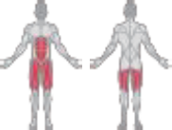 |  | 1 . standing stance:  stand on the machine with your feet positioned shoulder-width apart.
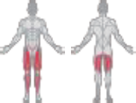 |  | 2 . squatting stance:  stand on the machine with your feet shoulder-width apart while maintain- ing a sauat position.
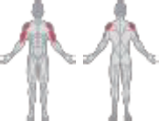 | 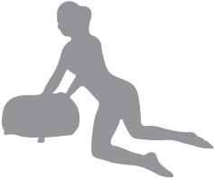 | 3 . upper body workout:  place your hands shoulder-width  apart on the pad while kneeling on your knees.
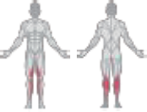 | 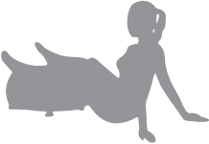 | 4 . Lower leg workout:  Rest your lower legs on the pad and support yourself by placing your  hands on the ground behind you.

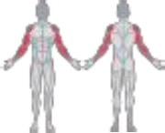 | 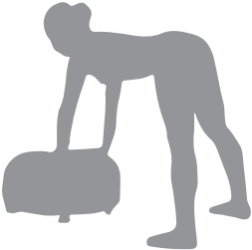 | 5 . Arm workout:  Bend at the waist with your Feet  shoulder-width apart and extend your arms straight to rest on the pad.
介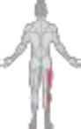 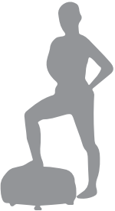 |  | 6 . single-foot stance:  place one foot on the machine and  stand in a relaxed and upright position.
介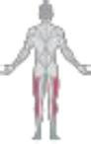 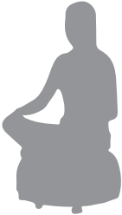 |  | 7. sitting stance I:  sit securely on the pad with your legs crossed.
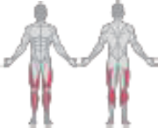 | 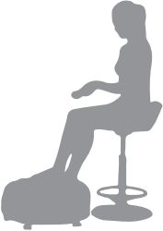 | 8 . sitting stance II:  place your legs on the pad while sitting on a stool or chair.

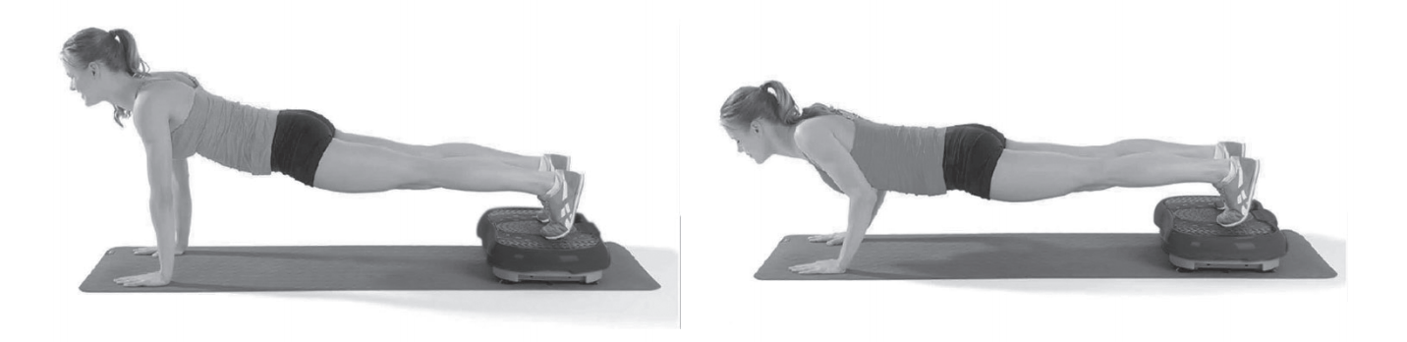

1 . push-up
starting position: place your legs on the vibration plate, with your knees bent and hands behind your head.
Exercise: Raise your upper body off the plate, but not fully,and then lower it back down.

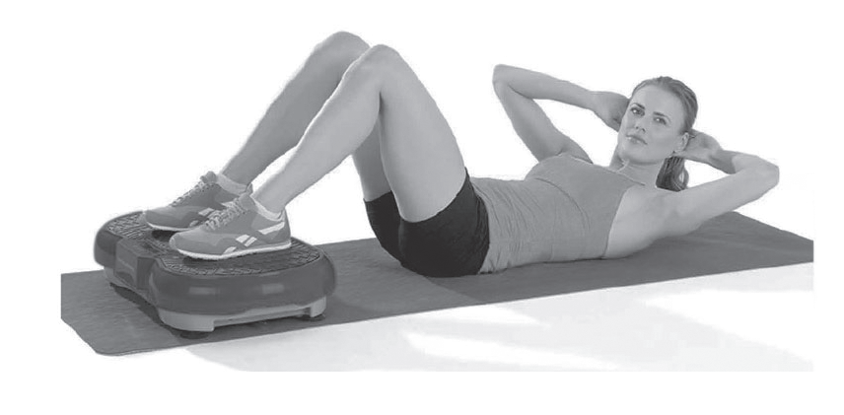

2 . sit-Ups
starting position: place your legs on the vibration plate, with your knees bent and hands behind your head.
Exercise: Raise your upper body off the plate, but not fully, and then lower it back down.

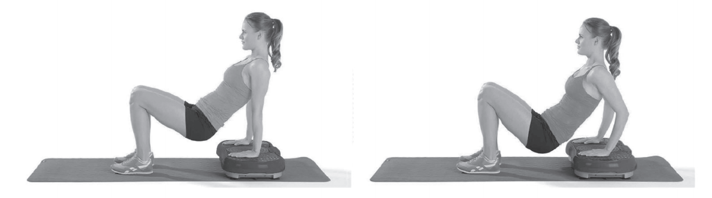

3 . Triceps Dip
starting position: Face away from the device, place your hands firmly on the plate, and support yourself on it.
Exercise: push your body up, slightly bending your elbows and lowering your upper body. keep your shoulder blades pressed together. Alternatively,you can extend your legs.

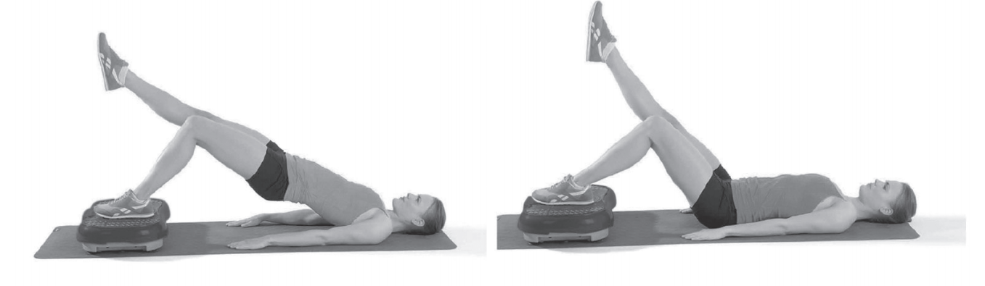

4 . Bridge on one Leg
starting position: Lie on your back on a mat in front of the device, with one foot stepping onthe plate.
Exercise: During the vibration , lift and extend one leg at a time,switch
ing legs every3 - 5 seconds. Make sure to keep your pelvis stable and not tilted to one side.

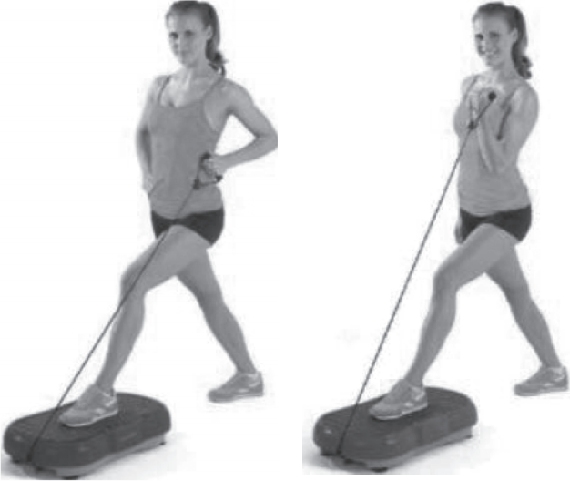
5. Lunge with Bands
starting position: place one foot in the middle of the device and extend the other leg backward. Hold one resistance band firmly.
Exercise: keep your back straight and firmly press your foot onto the plate, engaging the leg muscles. Bend your forearm and
alternately pull the resistance band upwards and back.
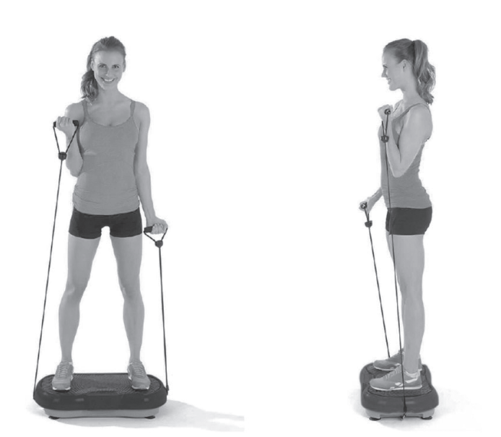
6 . Biceps curls
starting position: stand on the device and hold both resistance bands firmly.
Exercise: Maintain a straight back and wrists. Bend your elbows and pu1 1 the bands firmly upward.

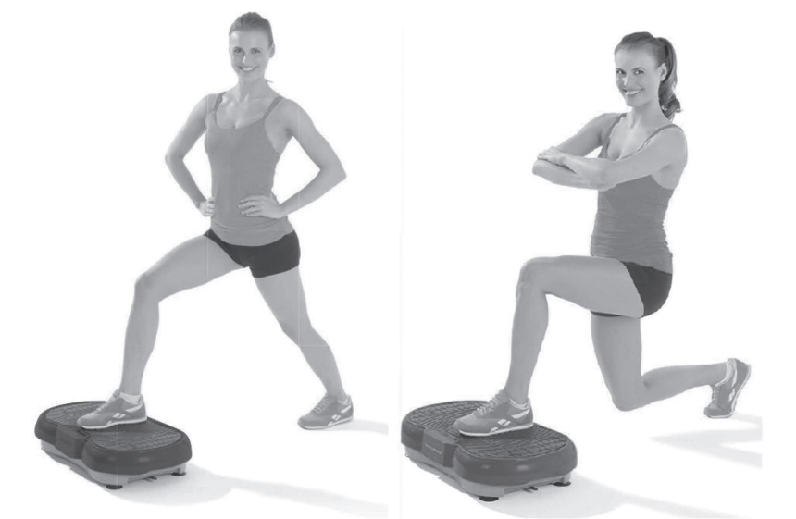

7. Lunge
starting position: place one foot in the middle of the device, with the other leg extended backward.
Exercise: Maintain a straight back and firmly press the front foot onto the vibration plate. Engage your leg muscles and cross your arms in front of your body.
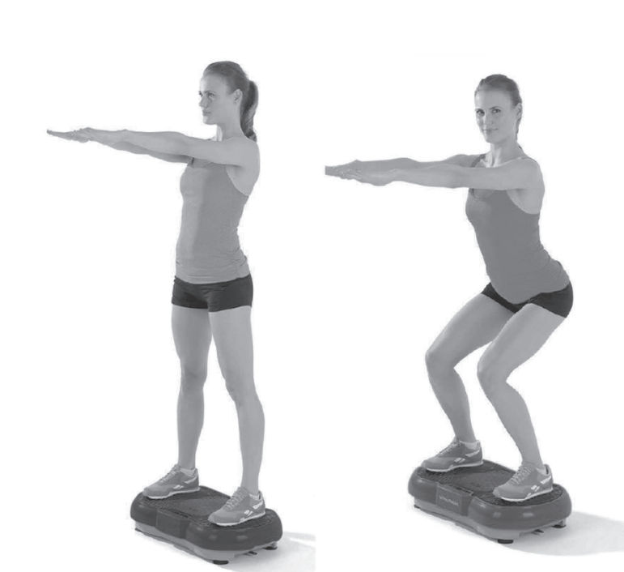
8 . squat
starting position: stand on the device with your feet shoulder-width apart.
Exercise: Maintain a straight back, slightly bend your knees and upper body forward , and engage your leg muscles. Alternatively, move up and down in a squatting motion.

 | 
 | Lights are off | power supply issue | check the power  supply and plug it in again.
 | Lights are off | power switch is off | Turn on power  switch on the back of unit
 | Lights are off | Blown fuse due to power surge | If the fuse is blown ,  replace it with a  new one.
2 | Noise | uneven fl oor or improper leveling of the foot screw | Adjust the foot  screw to ensure it is level with the fl oor.
3 | Remote  control  does not  work | Battery is not inserted or battery is empty | check the battery  and replace it if  necessary.
3 | Remote  control  does not  work | Too far from the machine | Make sure you are  within the valid  range of2 .5 meters  from the machine.
 | Machine stops while in use | Machine is overheated | AIlow the machine  to cool down for  1 0 minutes and  then start it again.
 | Device not responding | Too many commands entered at once | Turn off the power,  wait a few seconds,  and restart  the machine.
If the issue persists or you encounter any other problems, please refer to the user
manual or contact customer support for further assistance.



