
FOLDING TREADMILL Model#TM2305
LIFE SMART® is a registered trademark of
Supply Chain Sources LLC., All Rights Reserved.

Operating Instructions Manual
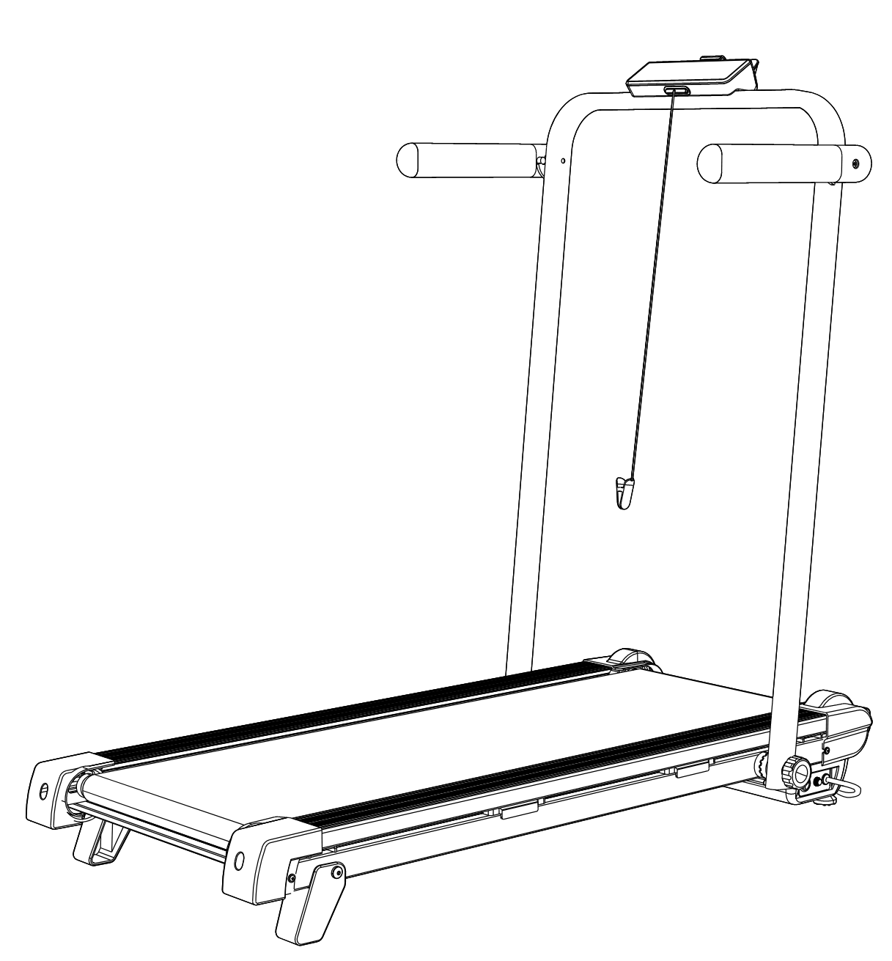

Special tips:
1.Before installation and operation, please read this operation manual carefully.
2.Please save this manual for future reference.
3.Product may vary slightly from the item pictures due to model upgrades.


Questions, problems, missing parts? Contact technical support department at 657-341-0362, 9:00 a.m. - 5 p.m., PST, Monday - Friday or contact us via email at support@scsources.com.
Please have your model and serial number ready
Scan QR Code to Visit Registration Page:

TABLE OF CONTENTS

ELECTRICAL SAFETY INSTRUCTION 1
IMPORTANT SAFETY INSTRUCTION 2
IMPORTANT OPERATING INSTRUCTIONS 3
ASSEMBLY PARTS AND TOOLS REQUIRED 4
ASSEMBLE THE TREADMILL 5-7
HOW TO ADJUST THE SLOPE&HANDLE BAR 8
HOW TO FOLD&MOVE THE TREADMILL 9
IMPORTANT ELECTRICAL INFORMATION 10
WALKING&RUNNING MODE 11
OPERATION GUIDE 12-16
TROUBLESHOOTING 17-18
MAINTENANCE & CARE 19
LUBRICATING THE TREADMILL 20
EXPLODED DRAWING 21
PARTS LIST 22
ONE-YEAR LIMITED WARRANTY 24

ELECTRICAL SAFETY INSTRUCTION

When using an electrical appliance, basic precautions should always be followed, including the following: Read all instructions before using this treadmill.

DANGER–To reduce the risk of electrical shock:Always unplug this appliance from the electrical outlet immediately after using and before cleaning.

WARNING–To reduce the risk of burns, fire, electric shock, or injury to persons:
- The treadmill should never be left unattended when plugged in. Unplug from the outlet when not in use and before putting on or removing parts.
- Use this treadmill only for its intended use as described in this manual. Do not use attachments not recommended by the manufacturer.
- Never operate this treadmill if it has a damaged cord or plug, if it is not working properly, if it has been dropped or damaged, or dropped into water. Return this treadmill to a service center for examination or repair.
- Keep the cord away from heated surfaces.
- Never operate the treadmill with the air openings blocked. Keep the air openings free of lint, hair, and alike items.
- Never drop or insert any object into any opening.
- Do not use outdoors.
- Do not operate where aerosol (spray) products are being used or where oxygen is being administered.
- To disconnect, turn the treadmill off, then remove plug from outlet.
- Connect this treadmill to a properly grounded outlet only. See grounding instructions.

CAUTION–To avoid injury, use extreme caution when stepping onto or off of a moving belt. Read instruction manual before using.

IMPORTANT SAFETY INSTRUCTION
To ensure your safety and health, please use this equipment correctly. It is important to read this entire manual before assembling and using the equipment. Safe and effective use can only be achieved if the equipment is assembled, maintained, and used properly. It is your responsibility to ensure that all users of the equipment are informed of all warnings and precautions.

- Before starting any exercise program, you should consult your physician to determine if you have any medical or physical conditions that could put your health and safety at risk or prevent you from using the equipment properly. Your physician’s advice is essential if you are taking medication that affects your heart rate, blood pressure or cholesterol level.
- Be aware of your body’s signals. Incorrect or excessive exercise can damage your health. Stop exercising if you experience any of the following symptoms: pain, tightness in your chest, irregular heartbeat, shortness of breath, dizziness, or feelings of nausea. If you do experience any of these conditions, you should consult your physician before continuing with your exercise program.
- Keep children and pets away from the equipment. The equipment is designed for adult use only.
- Use the equipment on a solid, flat level surface with a protective cover for your floor or carpet. To ensure safety, the equipment should have at least 8 feet (240CM) of free space behind it and 2 feet (60CM) on each side. Do not place the treadmill on any surface that blocks air openings. To protect the floor or carpet from damage, place a mat under the treadmill.
- Ensure that all nuts and bolts are securely tightened before using the equipment. The safety of the equipment can only be maintained if it is regularly examined for damage and/or wear and tear.
- Always use the equipment as indicated. If you find any defective components while assembling or checking the equipment, or if you hear any unusual noises coming from the equipment during exercise, discontinue use of the equipment immediately and do not use until the problem has been rectified.
- Wear suitable clothing while using the equipment. Avoid wearing loose clothing that may become entangled in the equipment.
- Do not place fingers or objects into the moving parts of the equipment.
- The equipment is not suitable for therapeutic use.
- To avoid bodily injury and/or damage to the product or property, proper lifting and moving is required.
- Your product is intended for use in cool, dry conditions. You should avoid storage in extreme cold, hot or damp areas as this may lead to corrosion and other related problems.
12.This equipment is designed for indoor and home use only, it is not intended for commercial use.

IMPORTANT OPERATING INSTRUCTIONS

- Insert the power plug directly into the socket.
- Read the manual before operating the equipment.
- Changes in speed do not occur immediately.
- While on the treadmill, move with caution as distractions may cause you to lose balance and stray from walking in the center of the belt. This may result in serious injury.
- This unit starts at a low speed. To begin use, stand on the side rails while it starts up, then step onto the belt once it’s in motion.
- A safety key is provided for emergency use. The treadmill will function only if the safety key is inserted into the computer console. In case of emergency, remove the safety key to immediately stop the belt and shut off the treadmill. The display screen will reset once the safety key is reinserted.
- This equipment is designed for adult use only! Children should not be allowed to use or play near this equipment. When present, children should always be supervised by an adult.
- Women who are pregnant or nursing should consult a physician before attempting to begin any exercise program.
- Always stay hydrated during and after exercise.
- Do not lift the treadmill.
- The belt must be lubricated before the first use.

ASSEMBLY PARTS AND TOOLS REQUIRED

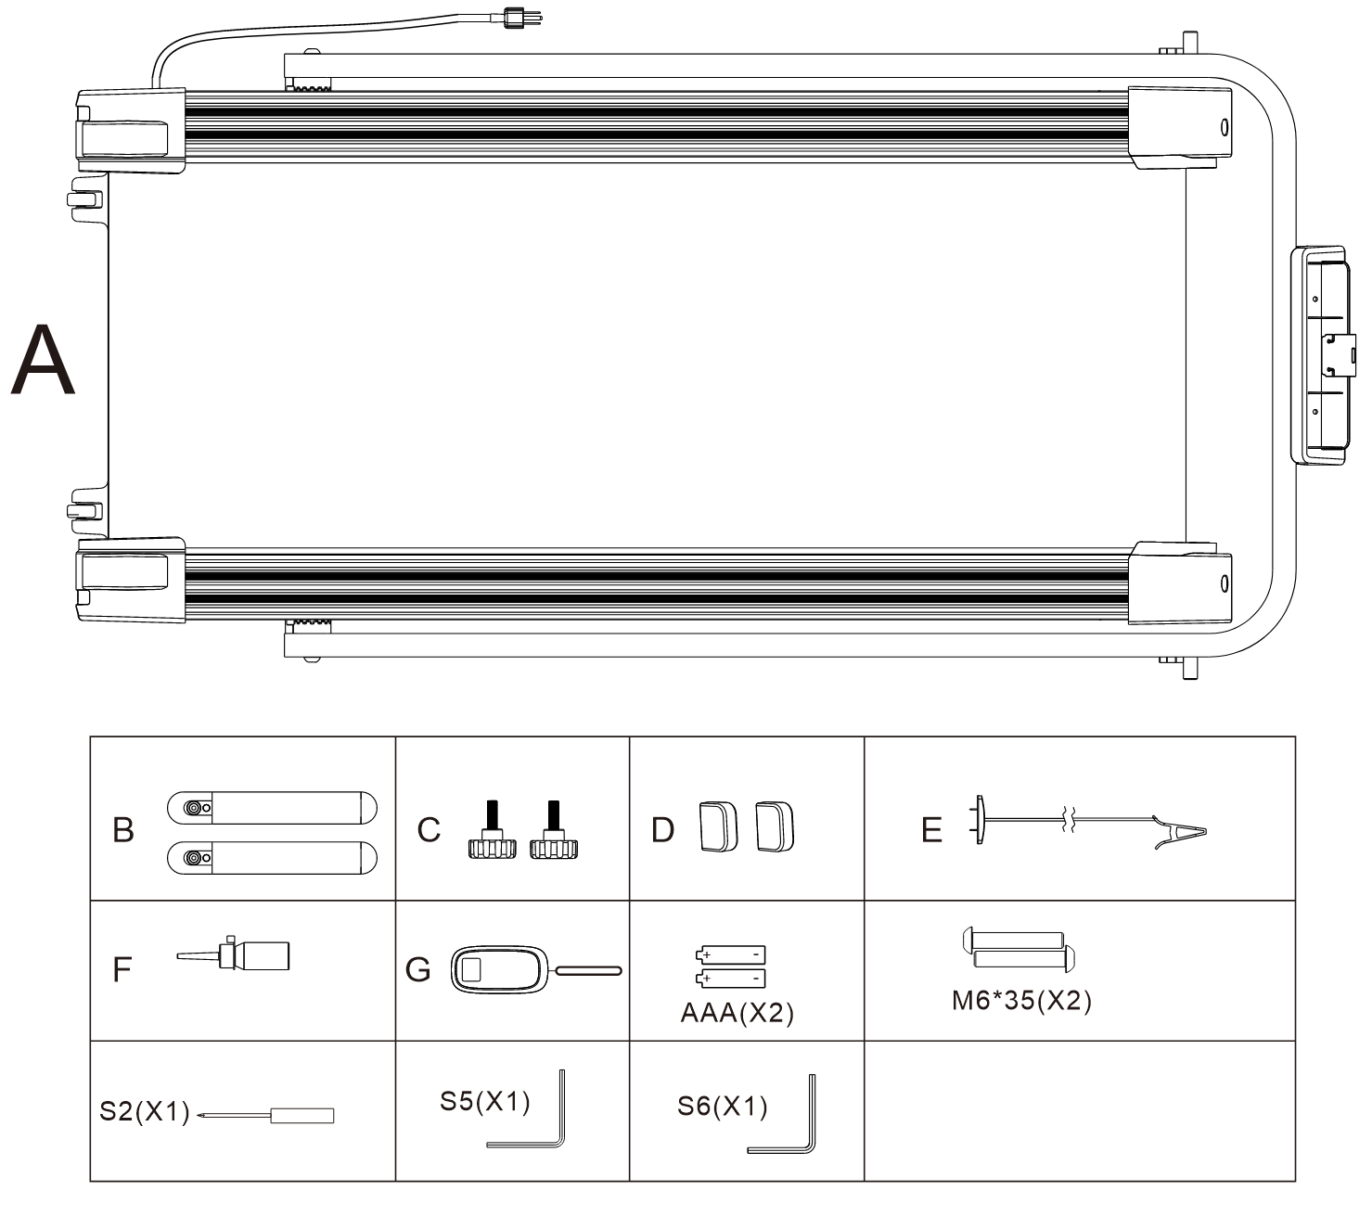

ASSEMBLE THE TREADMILL

STEP 1：
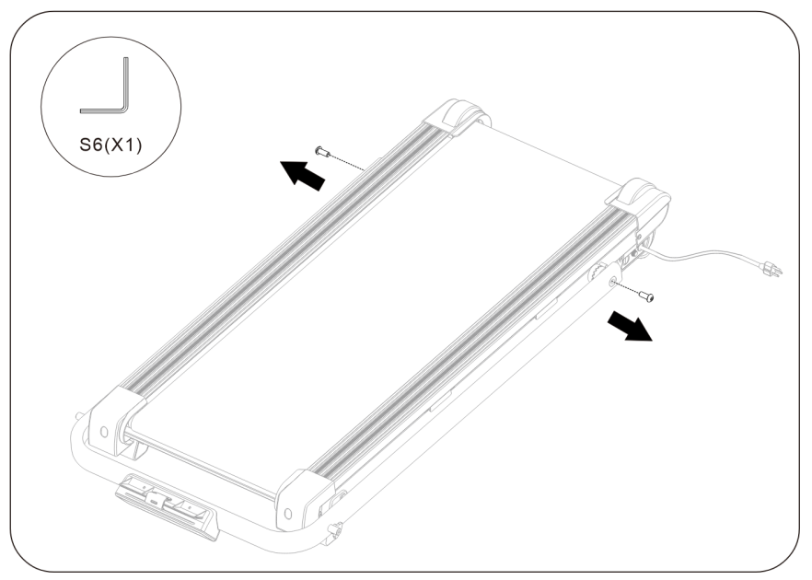
STEP 2:
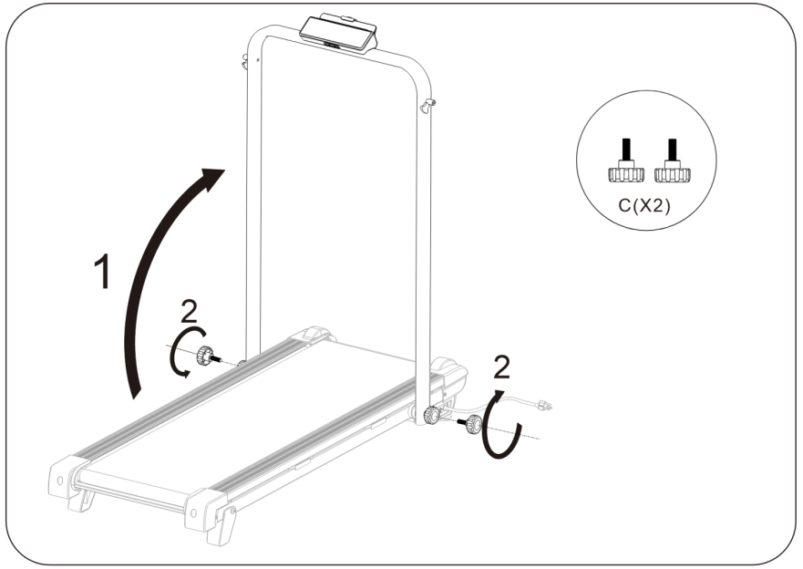

STEP 3:

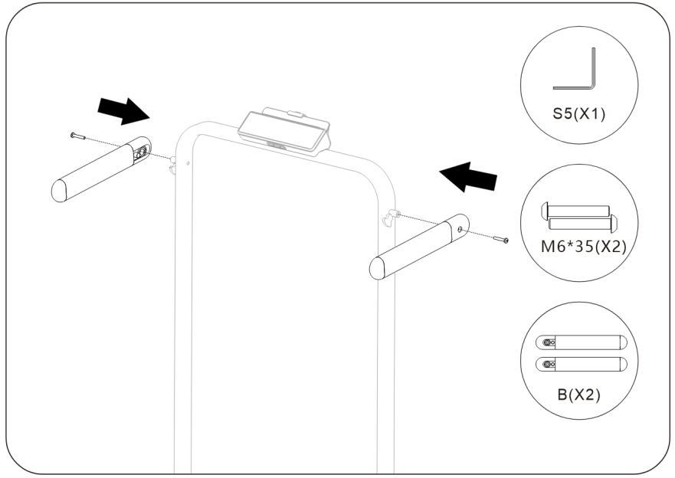

STEP 4
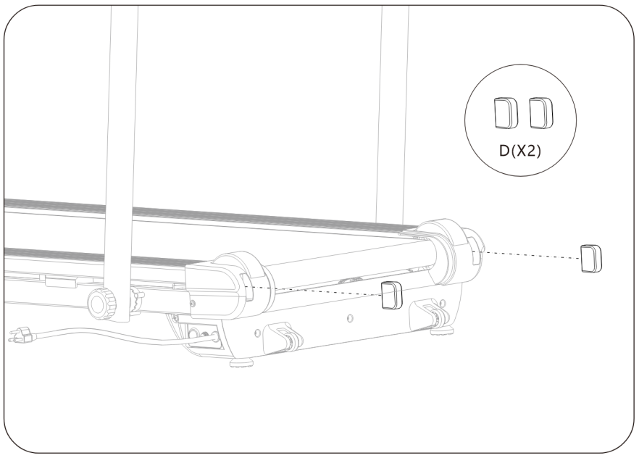

STEP 5:
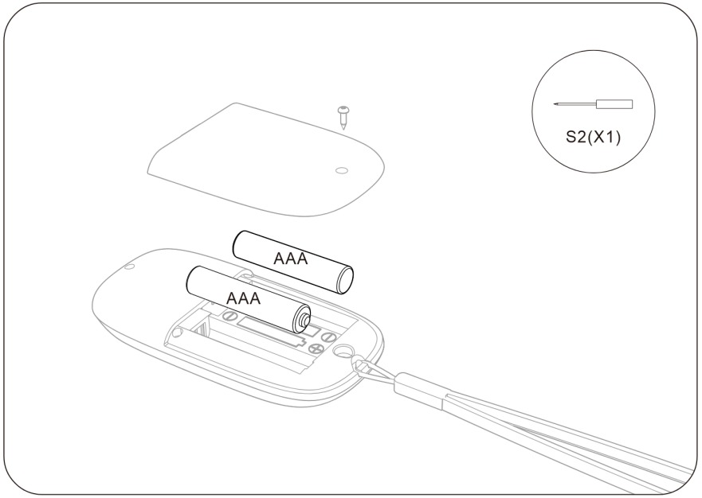

STEP 6:
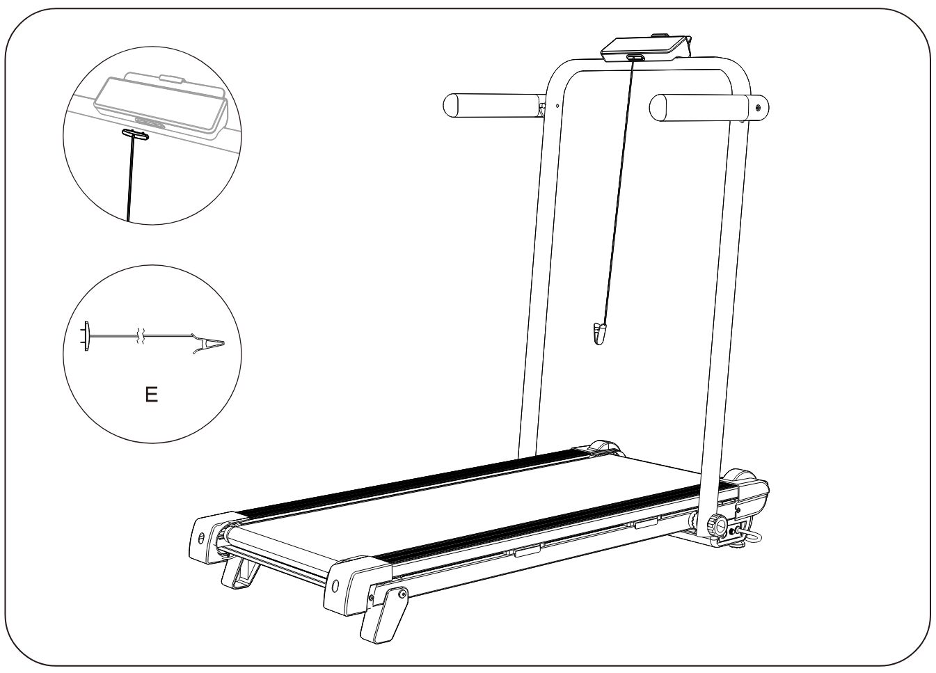

HOW TO ADJUST THE SLOPE

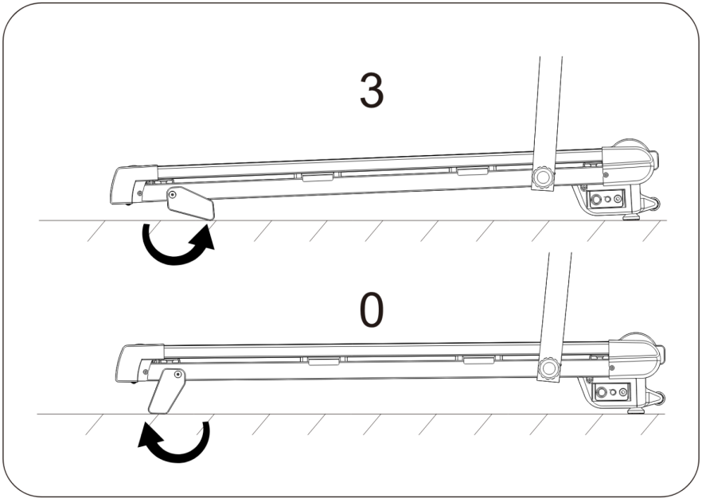

HOW TO ADJUST THE HANDLE BAR

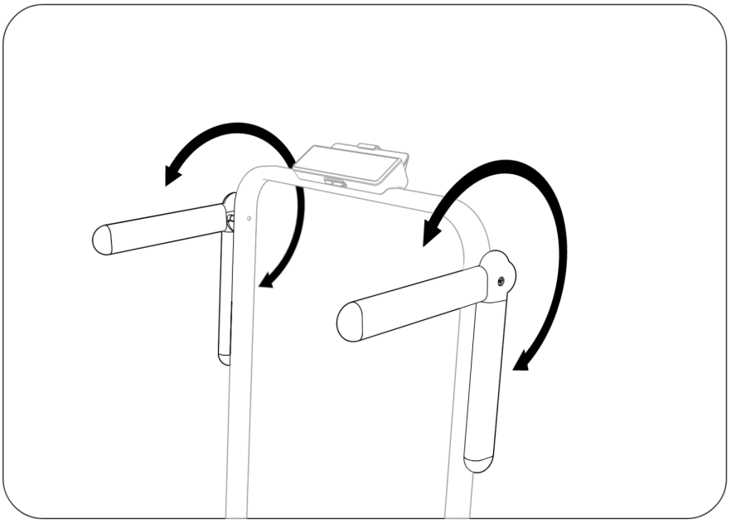
HOW TO FOLD THE TREADMILL
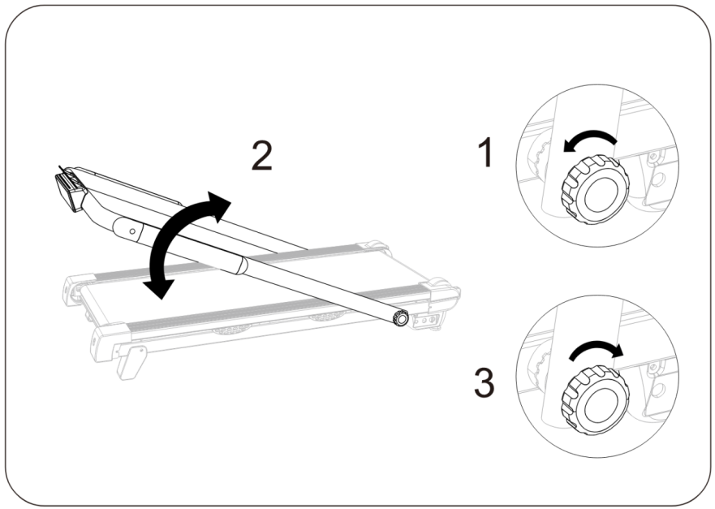

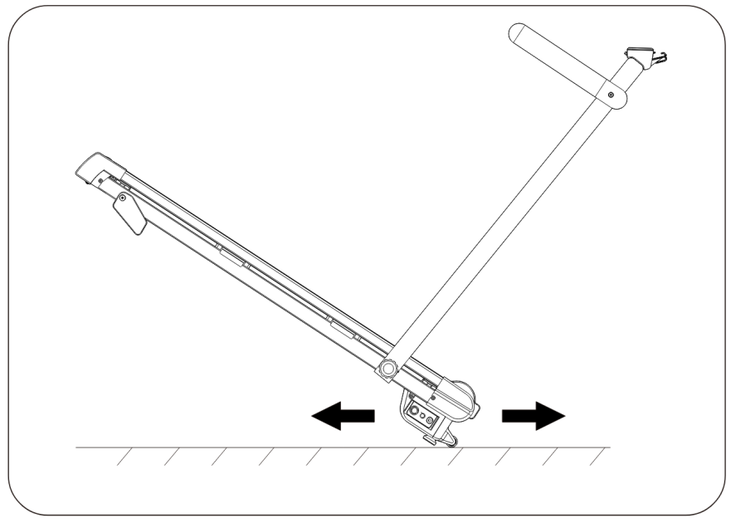
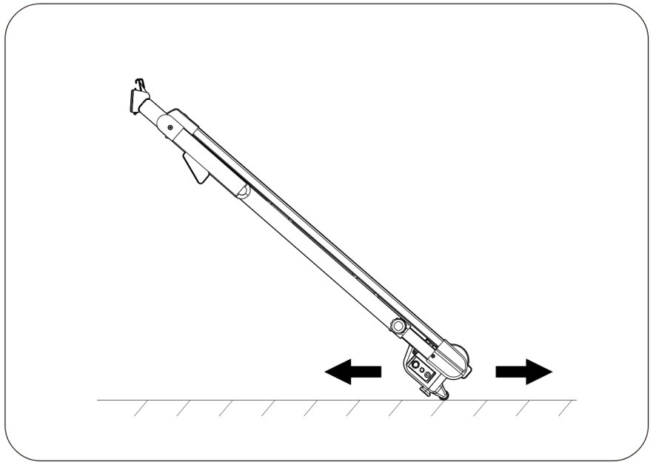
HOW TO MOVE THE TREADMILL

IMPORTANT ELECTRICAL INFORMATION

WARNING:
This treadmill requires a right power source in order to properly operate. For your safety, as well as the safety of others, please verify that the power source is correct before plugging the equipment. Any incorrect power source could cause significant damage to the equipment and or user.
GROUNDING METHODS:
This product must be grounded. Grounding provides the least resistance for electrical current and will reduce the risk of electric shock. The plug must be plugged into an appropriate outlet that is properly installed and grounded in accordance with all local codes and ordinances. Ensure that the product is connected to an outlet which contains the same configuration as the plug. Do not use an adaptor for this product.
This product is for use on a nominal circuit and has a grounding plug that is illustrated in sketch A. Make sure that the product is connected to an outlet having the same configuration as the plug. No adapter should be used with this product.
DANGER:
Improper connection of the equipment-grounding conductor can result in risk of electric shock. Check with a certified electrician if you are in doubt as to whether the product is properly grounded. Do not modify the plug provided with the product. If it will not fit the outlet, have a proper outlet installed by an electrician.
WARNING!
- NEVER use a ground fault circuit interrupt (GFCI) wall outlet with this treadmill. Route the power cord away from any moving part of the treadmill including the elevation mechanism and transport wheels.
- NEVER operate the treadmill using a generator or UPS power supply.
- NEVER remove any cover without first disconnecting power.
- NEVER expose the treadmill to rain or moisture. This treadmill is not designed for use outdoors, near pools or in any other high humidity environment.
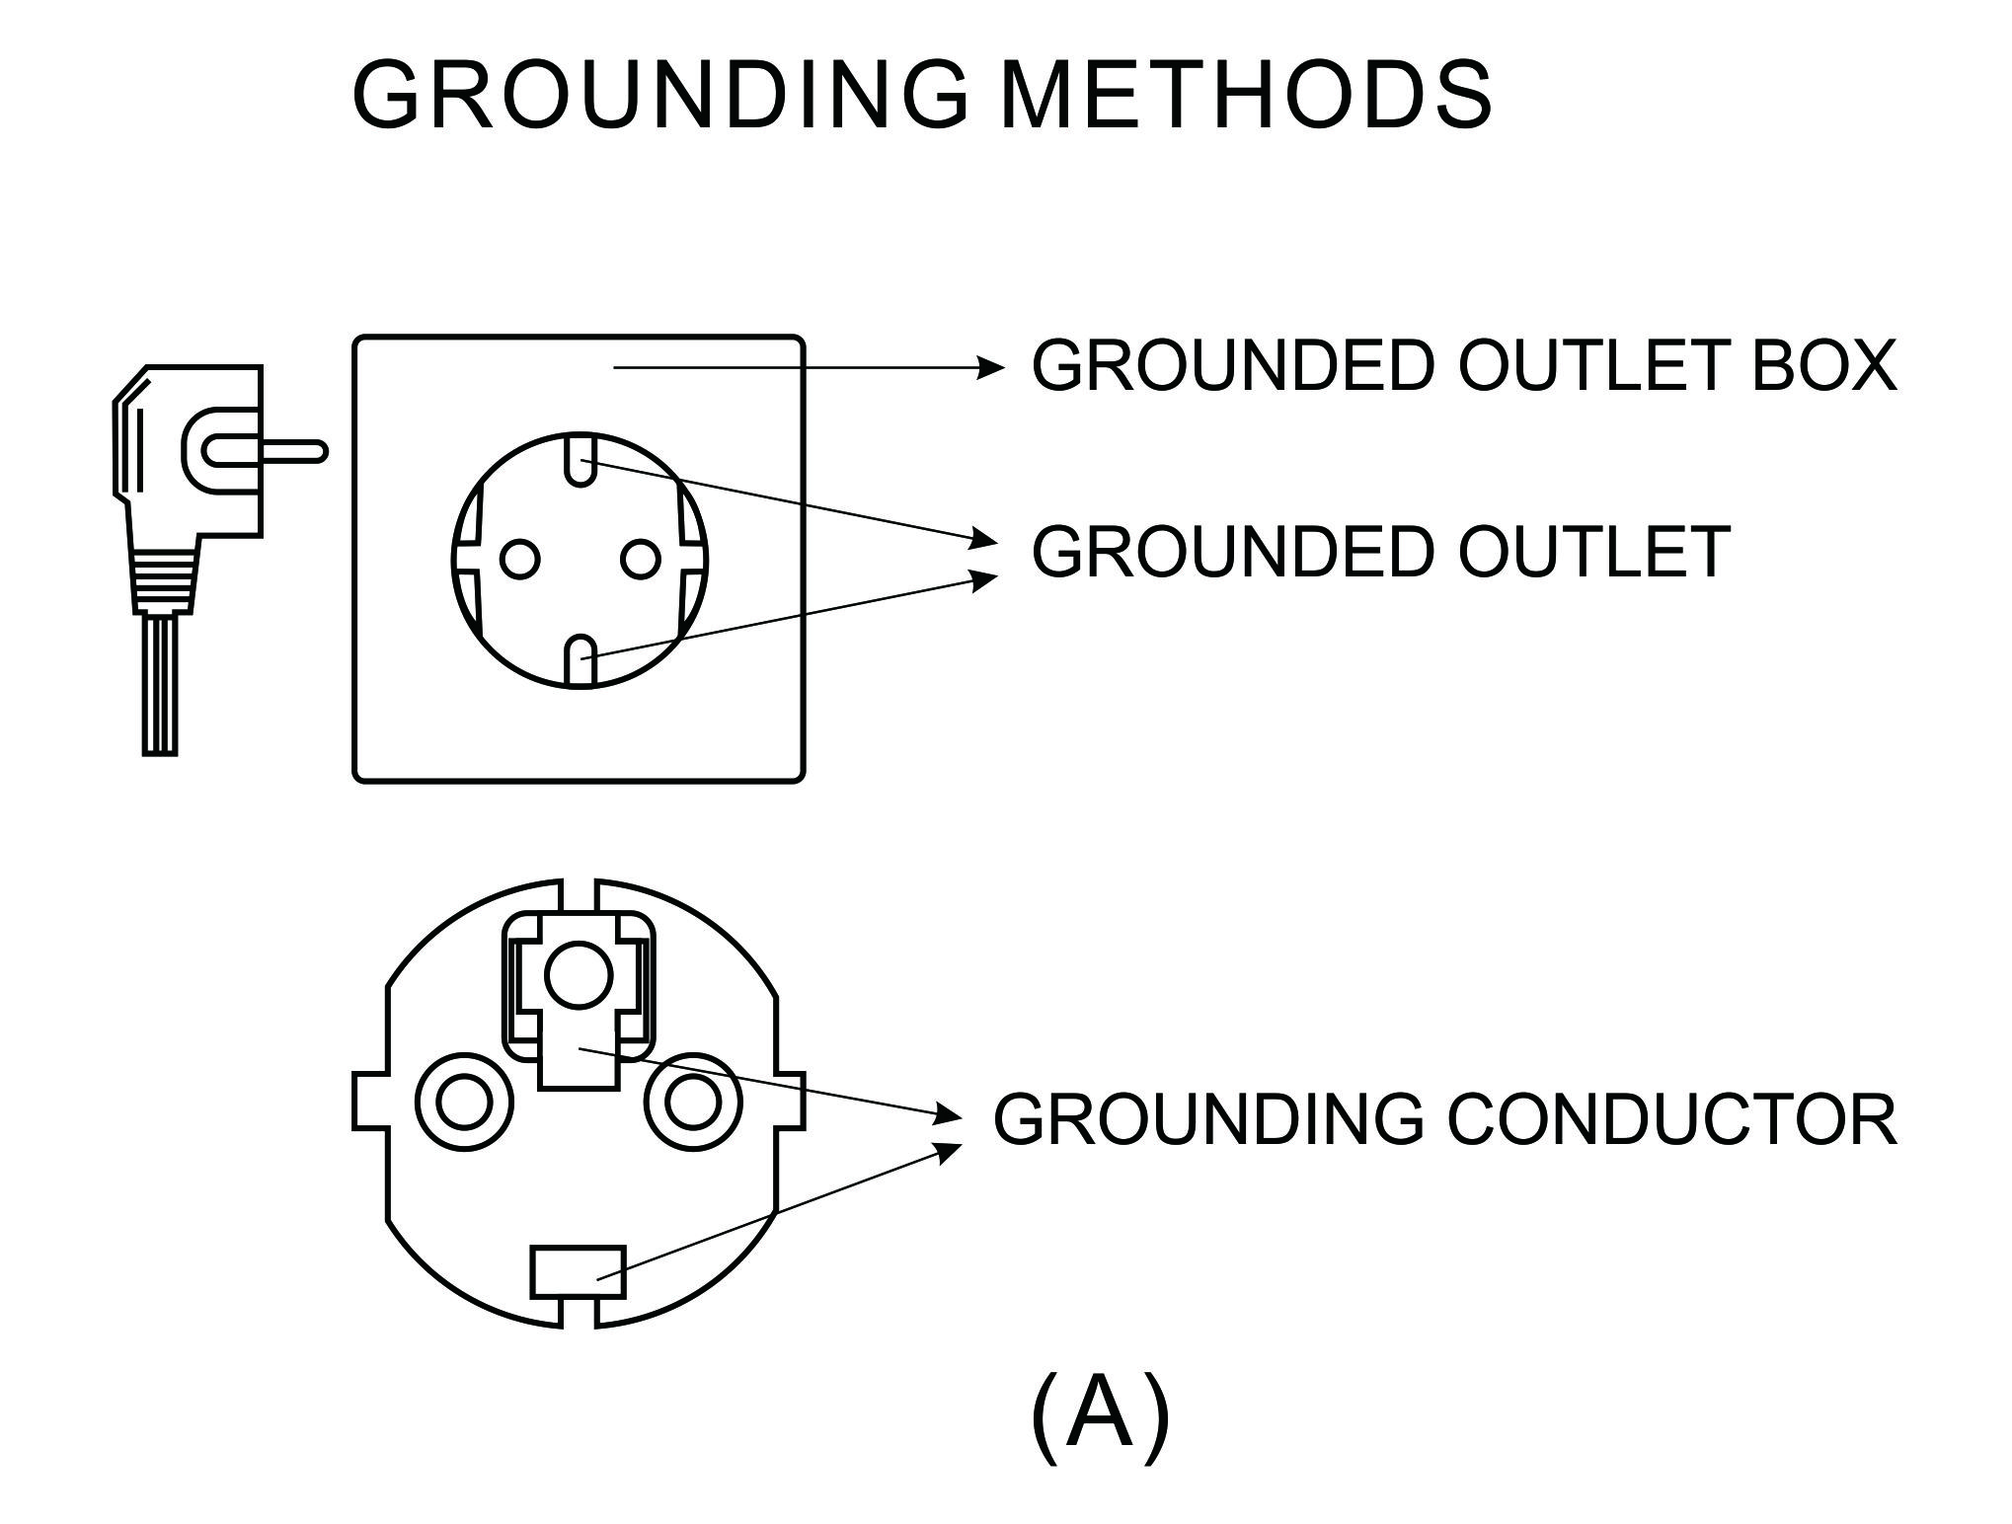

WALKING MODE&RUNNING MODE

This machine can transfer between walking mode and running mode.

WLAKING MODE:
When machine is folded flat, it can be used as walking treadmill, during walking mode, the speed rang is from 0.6-3.7mph.

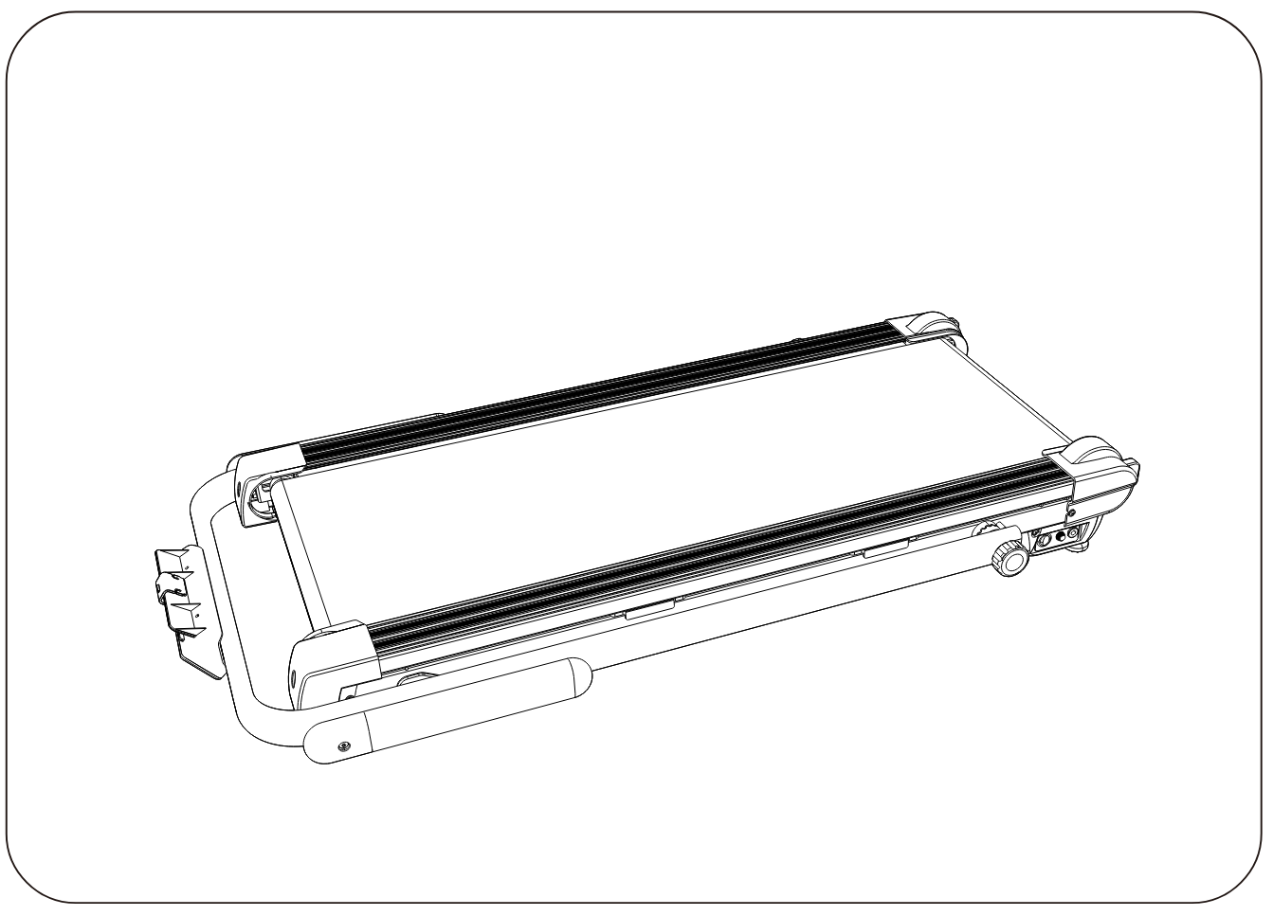
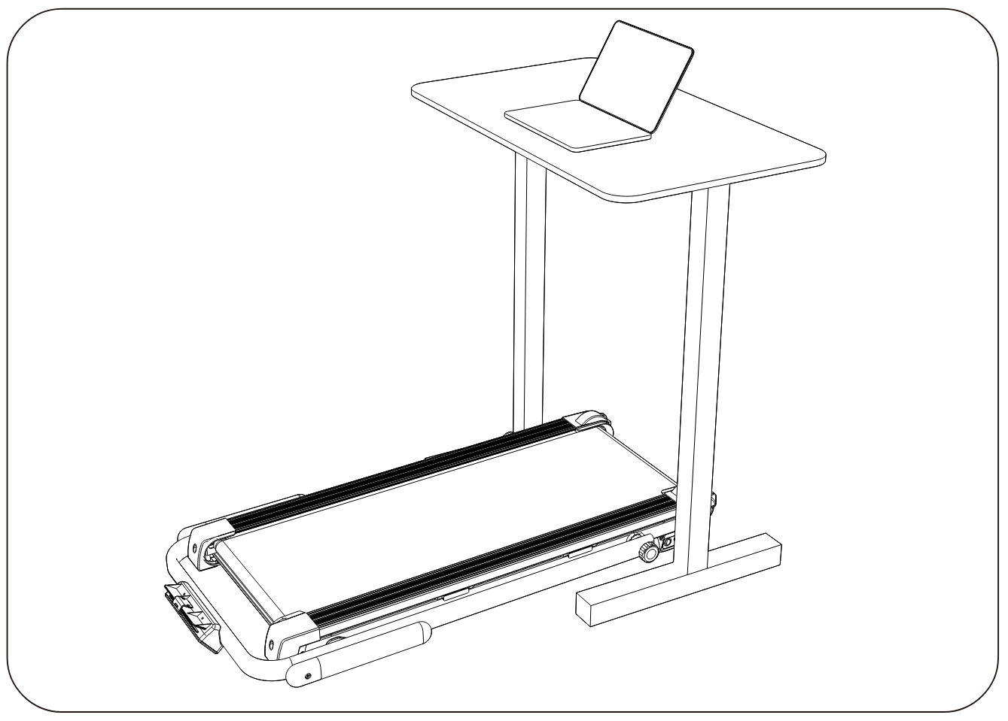

RUNNING MODE:
When machine is unfolded,can be used as running treadmill, during running mode, the speed rang is from 0.6-7.5mph.
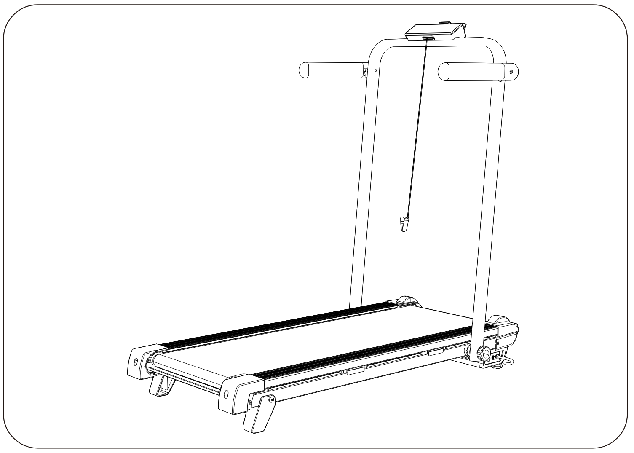

OPERATION GUIDE

DIGITAL DISPLAY：

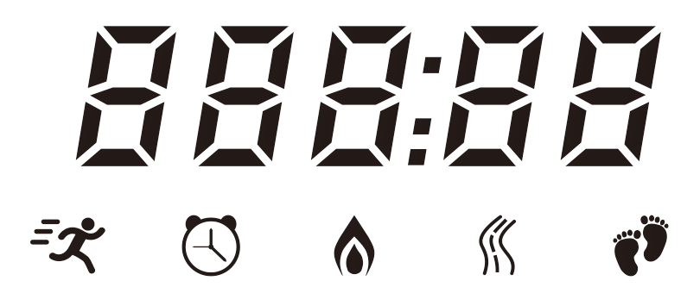
- : Display current speed. Press SPEED+/- to adjust the speed of the machine.
- : Displays the time elapsed. Display starts at 0:00. When time elapsed reaches the maximum, the machine will continue running. It will start count again from 0:00.
- : Display the consumed calories.
- : Display current distance.
- : Displays steps that the user has walked.

Speed/Time/Calories/Distance/Steps share the same window and will show in turn every 3 seconds.
Under walking or running mode:
Press “PROG.” button to show Speed/Time/Calories/Distance/Steps one by one without in turn.
Press “MODE” button will show Speed/Time/Calories/Distance/Steps in turn every 3 seconds.

CONSOLE BUTTON FUNCTION：

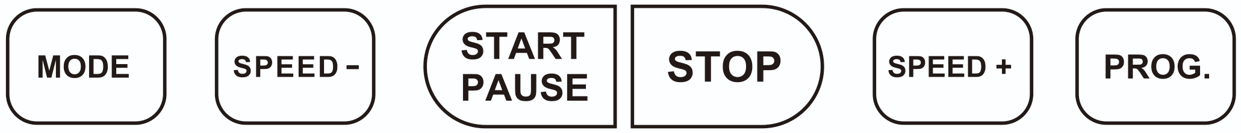

- MODE: Under standby mode, press this button to choose from time count down, distance count down, and calories count down.

1.1 TIME COUNT DOWN
Under standby mode, when no program is selected, press MODE button repeatedly until count down function is displayed. Press “SPEED-” “SPEED+” buttons to set time. Press “START/PAUSE” button to start.

1.2 DISTANCE COUNT DOWN
Under standby mode, when not choosing any programs, press MODE button until you find distance count down window. Press “SPEED-” “SPEED+” buttons to set time. Press “START/PAUSE” button to start.

1.3 CALORIES COUNT DOWN
Under standby mode, when not choosing any programs, press MODE button until you find calories count down window. Press “SPEED-” “SPEED+” buttons to set time. Press “START/PAUSE” button to start.

- SPEED-: Press this button to decrease the speed.
- START/PAUSE: Press this button to start or pause, after pause, press this button again to restart.
- STOP: Press this button to stop, all data will come to 0 if you press this button.
- SPEED+: Press this button to increase the speed.
- PROG.:
Under standby mode, press this button to choose from 9 default programs. Press “SPEED-” “SPEED+” buttons to set target time for each program. Press “START/PAUSE” to start.

Each program is divided into 10 sections. During each section, you can adjust speed by pressing “SPEED-” “SPEED+” buttons. The treadmill will beep when it enters into the next section, and the speed will recover to default setting.When finish all sections, the machine will gradually come to a stop.

Time interval=setting time/10
Under running mode (mph)
 |  | 1 | 2 | 3 | 4 | 5 | 6 | 7 | 8 | 9 | 10
P1 | SPEED | 1.9 | 2.5 | 3.1 | 3.7 | 3.7 | 2.5 | 3.1 | 3.7 | 3.7 | 2.5
P2 | SPEED | 2.5 | 3.1 | 3.7 | 4.3 | 4.3 | 3.1 | 3.7 | 4.3 | 4.3 | 3.1
P3 | SPEED | 3.1 | 3.7 | 4.3 | 5.0 | 5.0 | 3.7 | 4.3 | 5.0 | 5.0 | 3.7
P4 | SPEED | 3.7 | 4.3 | 5.0 | 5.6 | 5.6 | 4.3 | 5.0 | 5.6 | 5.6 | 4.3
P5 | SPEED | 3.7 | 5.0 | 6.2 | 6.2 | 5.0 | 5.0 | 6.2 | 6.2 | 5.0 | 3.7
P6 | SPEED | 4.3 | 5.6 | 6.2 | 5.6 | 6.2 | 5.6 | 6.2 | 5.6 | 6.2 | 4.4
P7 | SPEED | 4.3 | 5.6 | 5.6 | 4.3 | 4.3 | 5.6 | 5.6 | 4.3 | 5.6 | 4.3
P8 | SPEED | 3.1 | 6.2 | 6.2 | 3.1 | 3.1 | 6.2 | 6.2 | 3.1 | 6.2 | 3.1
P9 | SPEED | 3.7 | 6.2 | 6.2 | 3.7 | 3.7 | 6.2 | 6.2 | 3.7 | 6.2 | 3.7
Time interval=setting time/10
Under walking mode (mph)
 |  | 1 | 2 | 3 | 4 | 5 | 6 | 7 | 8 | 9 | 10
P1 | SPEED | 1.9 | 1.9 | 1.9 | 1.9 | 1.9 | 1.9 | 1.3 | 1.9 | 1.9 | 1.9
P2 | SPEED | 1.9 | 2.5 | 2.5 | 2.5 | 2.5 | 2.5 | 1.9 | 2.5 | 2.5 | 2.5
P3 | SPEED | 2.5 | 3.1 | 3.1 | 3.1 | 3.1 | 3.1 | 2.5 | 3.1 | 3.1 | 3.1
P4 | SPEED | 1.9 | 3.7 | 3.7 | 3.7 | 3.7 | 3.7 | 1.9 | 3.7 | 3.7 | 1.9
P5 | SPEED | 1.9 | 3.1 | 1.9 | 3.1 | 1.9 | 3.1 | 1.9 | 3.1 | 1.9 | 3.1
P6 | SPEED | 2.2 | 3.4 | 2.2 | 3.4 | 2.2 | 3.4 | 2.2 | 3.4 | 2.2 | 3.4
P7 | SPEED | 1.9 | 3.1 | 3.1 | 1.9 | 3.1 | 3.1 | 1.9 | 3.1 | 3.1 | 1.9
P8 | SPEED | 2.2 | 3.4 | 3.4 | 2.2 | 3.4 | 3.4 | 2.2 | 3.4 | 3.4 | 2.2
P9 | SPEED | 2.5 | 3.7 | 3.7 | 2.5 | 3.7 | 3.7 | 2.5 | 3.7 | 3.7 | 2.5

REMOTE CONTROL FUNCTION：
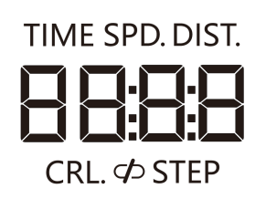
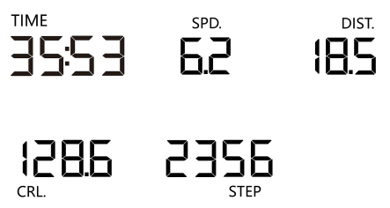
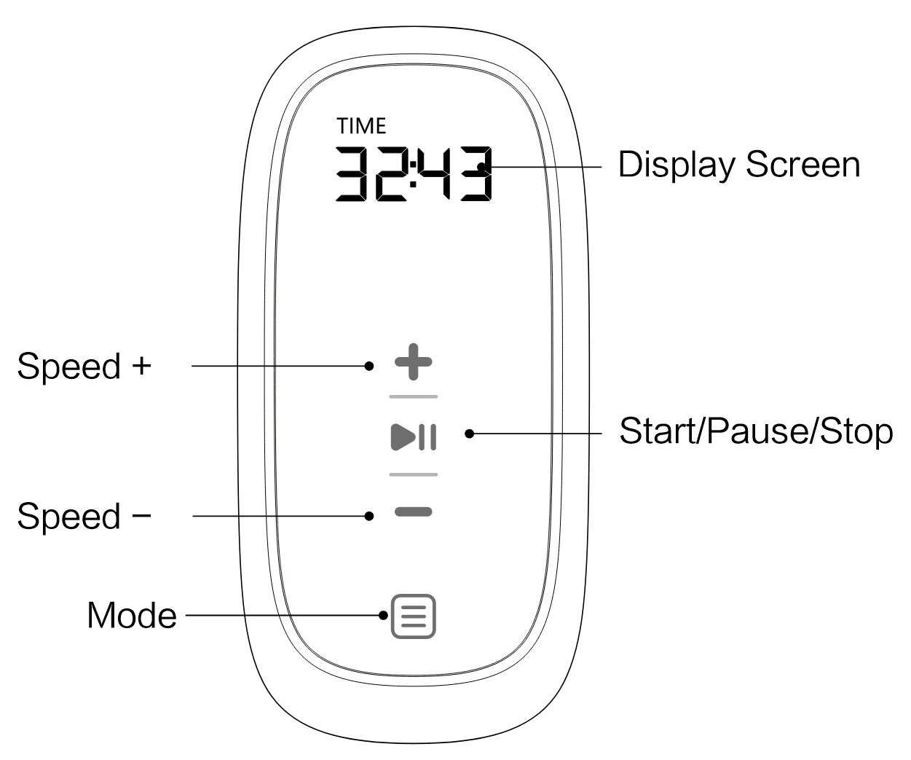

1.Speed+ : Press this button to increase the speed.
2.Start/Pause/Stop: Press this button to start or pause, after pause, press this button again to restart. Long press of this button will enter into stop.
3.Speed - : Press this button to decrease the speed.
4.Mode : Under standby mode, press this button to enter default programs and count down mode.
5.Display screen: This window will show Speed/Time/Calories/Distance/Steps in turn every 3 seconds.
6. ：Pairing indication light.
Usually speaking, the remote control is well paired with machine, no need to pair again.

When the machine powers off and above pairing indication light is on, it is normal.

But when the machine powers on and meanwhile this paring indication light is still on, it means that you need to pair first before using remote control. Please follow below steps to pair:

A.Power off the machine.
B.Press (Mode) button of remote control and hold on, meanwhile, please power on the machine, do not release holding until you see this light is off.
C.Once confirm this light is off, means paring is success, until now, your remote control is available.

BLUETOOTH FOR CONNECTION OF APP:
Kinomap App Connection:
Click FTMS icon in "My treadmill" interface.
Select Bluetooth name start with “MT8347” for connection.
Zwift App Connection:
Select Bluetooth name start with “MT8347” for connection.

LUBRICATION REMINDER FUNCTION:
This machine has lubrication remind function. After every total running distance of 187 mile (300km), your treadmill needs to be maintained with oil. The system will remind with sound for every 10 seconds, and window will show “OIL”. This means that your treadmill needs to be lubricated with oil. Please read the user’s manual first, and add oil to the middle part of running board. After the lubrication, please hold on “STOP” button for 3 seconds, and the system warning sound will disappear.

SWITHING BETWEEN KILOMETERS & MILES:
Under standby mode, hold on “STOP” button for 5 seconds, you can change between “mile” and “kilometer”. Display window will show “n” or “H”, “n” means “mile”, “H” means “kilometer”.

SAFETY LOCK FUNCTION:

Under any mode, if you pull away the safety key, the machine will stop. The window will show “---” with reminding sound. The machine cannot work until safety key is inserted back.

POWER SAVING FUNCTION:

The machine is with energy saving function. Under standby mode, if without any operation for 10 minutes, the system will enter into energy saving mode, the display will be closed up. You can press any button to turn on the display.

POWER ON () AND POWER OFF ()
Switch off the power: You can switch off the power to stop the treadmill, which won’t be damaged at any time.

CAUTION:

1. We recommend that you maintain a slow speed at the beginning of a session and hold on to the handrails until you become comfortable and familiar with the treadmill.

2. Insert the safety key into the treadmill console and also attach the clip of the safety stop rope to your clothing.

3. To end your workout safely, press the STOP button or pull out the safety stop rope, then the treadmill will stop immediately.
PROBLEM |  | POSSIBLE CAUSE | SUGGESTED ACTION
Treadmill will not start |  | Not plugged in | Plug cord into outlet
 |  | Safety Key not inserted  Display will show “----” | Insert Safety Key
Running belt not centered |  | Running belt tension not  correct on the left or right sides of the running board | Tighten the adjustment bolts on the left and right side of the rear roller
Display not working |  | Wires are not properly connected. | Check wire connections  from the PCB to the control board.
E01:  Software over current  E02:  Hardware over current |  | Over current | - Power off and then restart to check if machine can work.  2.If can not work, then need to change a new control board.
E03:  Too hot control board  protection | Over current  Damage of control board |  | 1.Power off and then restart to check if machine can work.  2.If can not work, then need to change a new control board.
E04:  Too low voltage protection | Too low voltage |  | 1.Power off and then restart to check if machine can work.  2.If can not work, then need to change a new control board.  3.If voltage is normal but machine can not work, then need to change a new control board.
E05:  Over voltage protection | Over voltage |  | 1.Power off and then restart to check if machine can work.  2.If can not work, then need to change a new control board.  3.If voltage is normal but machine can not work, then need to change a new control board.

TROUBLESHOOTING

E06-E09  Motor Abnormality | The incoming voltage is too low or too high. The control board is damaged. | - Restart the treadmill.  - Check the incoming voltage to ensure it’s correct. Replace the control board if necessary.
E06-E09  Motor Abnormality | A moving part of the treadmill is stuck and therefore the motor is unable to rotate properly. | - Inspect moving parts of the treadmill to ensure that they are operating correctly.  - Check the motor, listen for strange noise and check for a burning smell. Replace the motor if necessary.  - Check the control board, replace if damaged.  - Lubricate the treadmill.
E06-E09  Motor Abnormality | The motor wire is not connected or the motor is damaged. | - Check motor wires to see if the motor is connected.  - If the wire has been punctured or damaged, you will need to replace it.  - If the problem is not rectified, you may need to replace the motor.
E10:  Overload protection | Over current | - Over current, power off and then restart to check if machine can work.  - If the problem is not rectified, you may need to replace the control board or motor.
E11:  Communication failure | The communication failure | - Power off and then restart to check if machine can work.  - Check all connection wires from console to the control board.  - If the problem is not rectified, you may need to replace the control board or PCB board.

MAINTENANCE & CARE
General cleaning will help prolong the life and performance of your treadmill. Keep the unit clean and maintained by dusting the components on a regular basis. Clean both sides of the running belt to prevent dust from accumulating underneath the belt. Keep your running shoes clean so that dirt from your shoes does not wear out the running board and belt. Clean the surface of the running belt with a clean damp cloth. Children without supervision shall not do the cleaning or maintenance by themselves.
- To better maintain the treadmill and prolong its life it is suggested that the machine be powered off for 10 minutes every 2 hours and fully powered off whenever not in use.
- A loose Running Belt will result in the runner sliding off when running, while too tight of a Running Belt will result in decrease to the motors performance and also create more friction between the roller and running belts. The most suitable tightness for the belts is pulled out 50-75mm from the Running Board.

CENTERING THE RUNNING BELT:
Place the treadmill on level ground and set it at 3.7-5.6 mph. Center the running belt when one side of the running belt drifts.
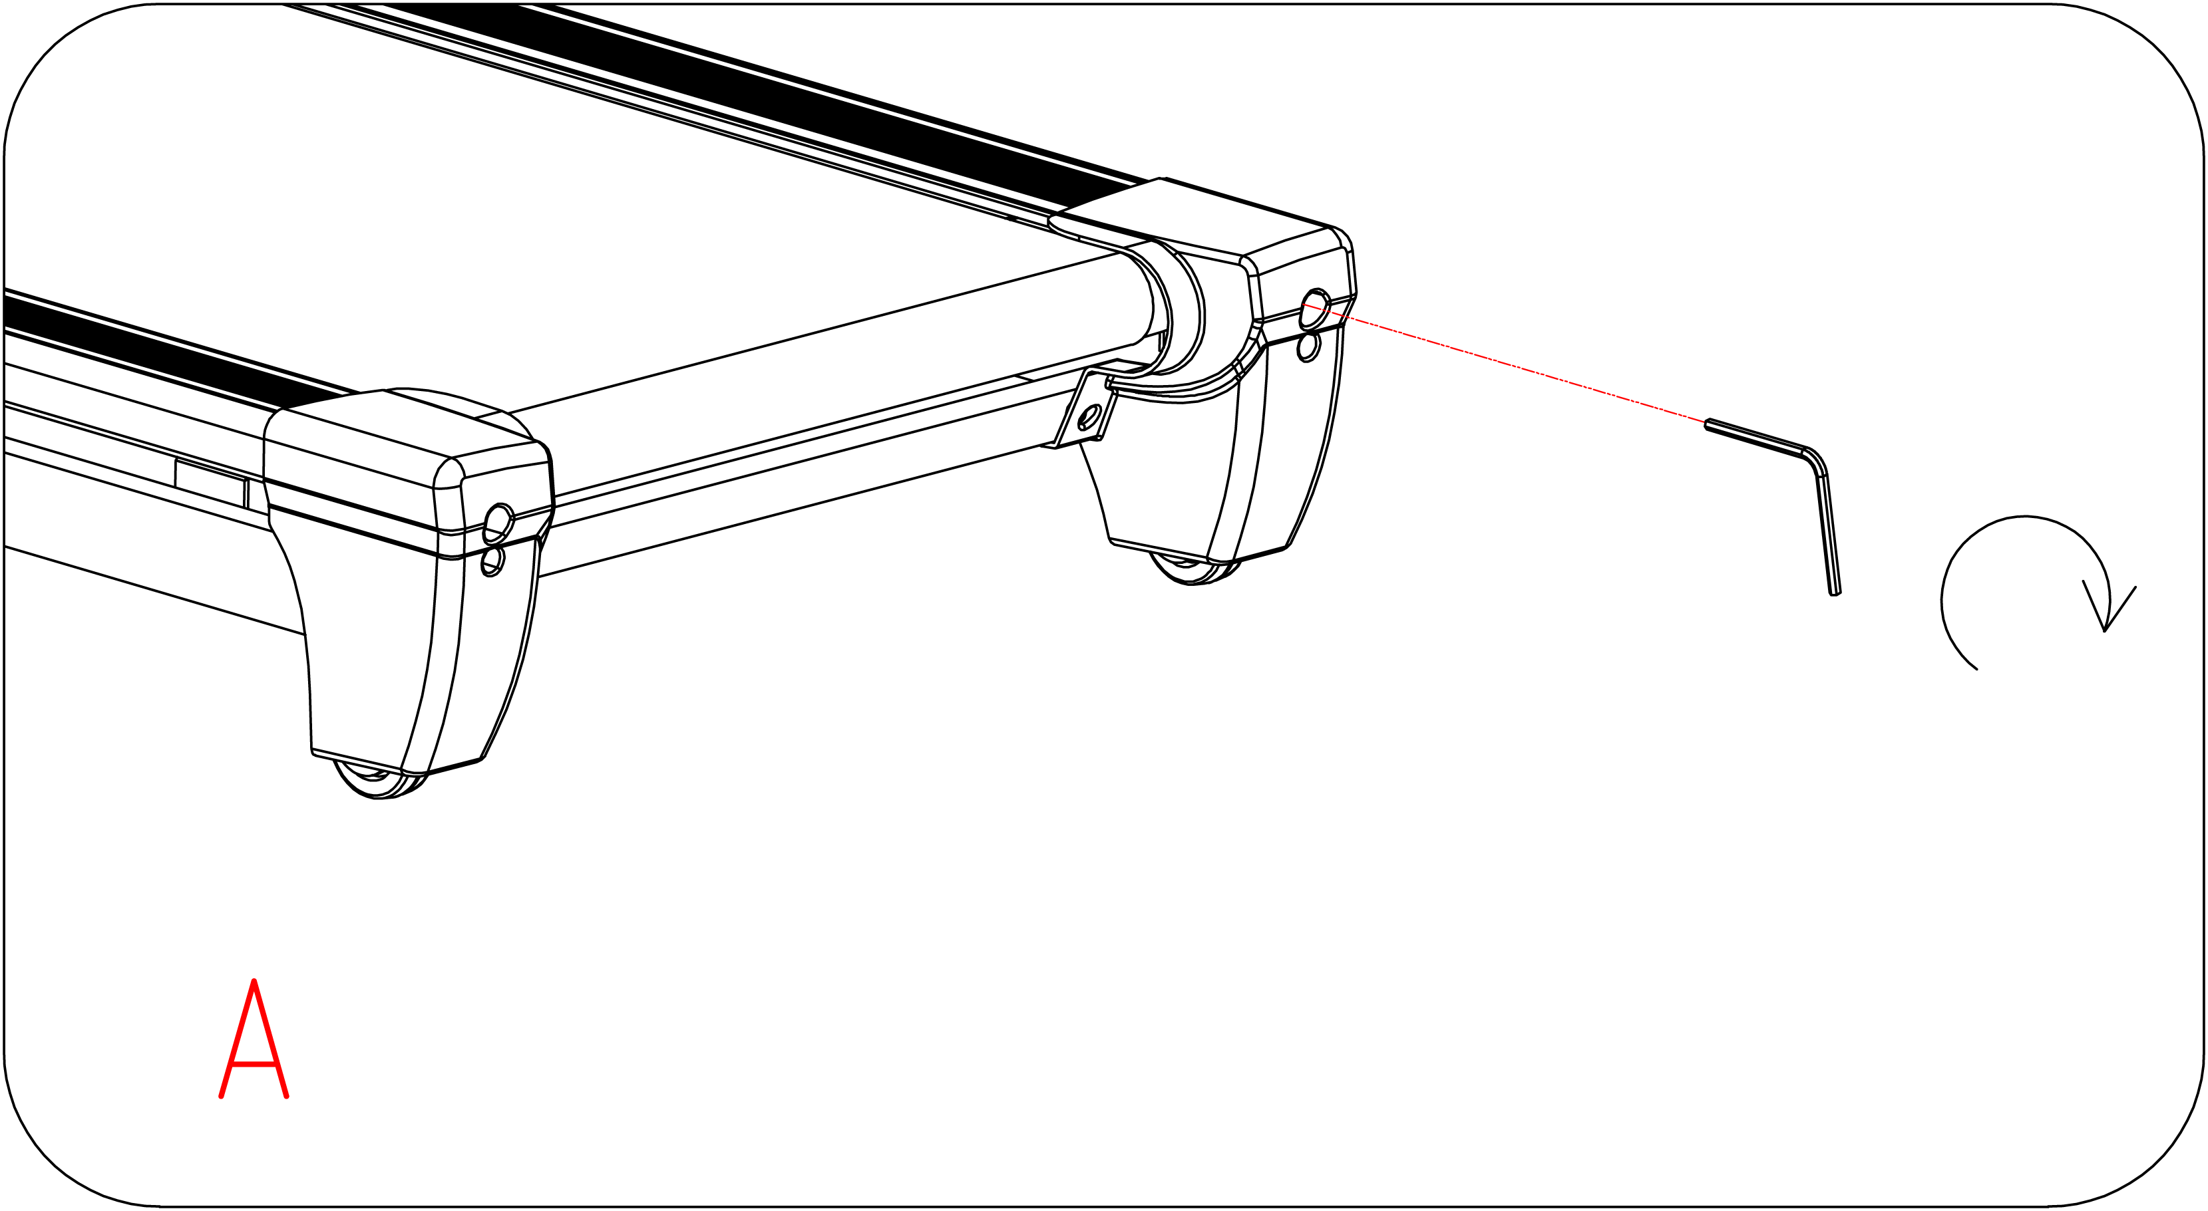
1. If the Running Belt moves to the right, turn the adjusting bolt on the right side ¼ turn clockwise, then turn the left adjustment bolt ¼ turn counter-clockwise. If the belt does not move, repeat this step until it centers. Refer to figure A.

2. If the Running Belt moves to the left, turn the adjusting bolts on the left side ¼ of a turn clockwise, then turn the right adjustment bolt ¼ turn counter-clockwise. If the belt does not move, repeat this step until it centers. Refer to figure B.
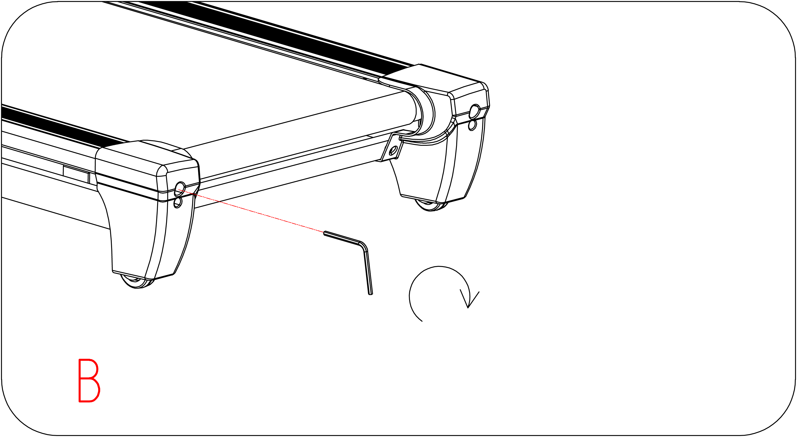

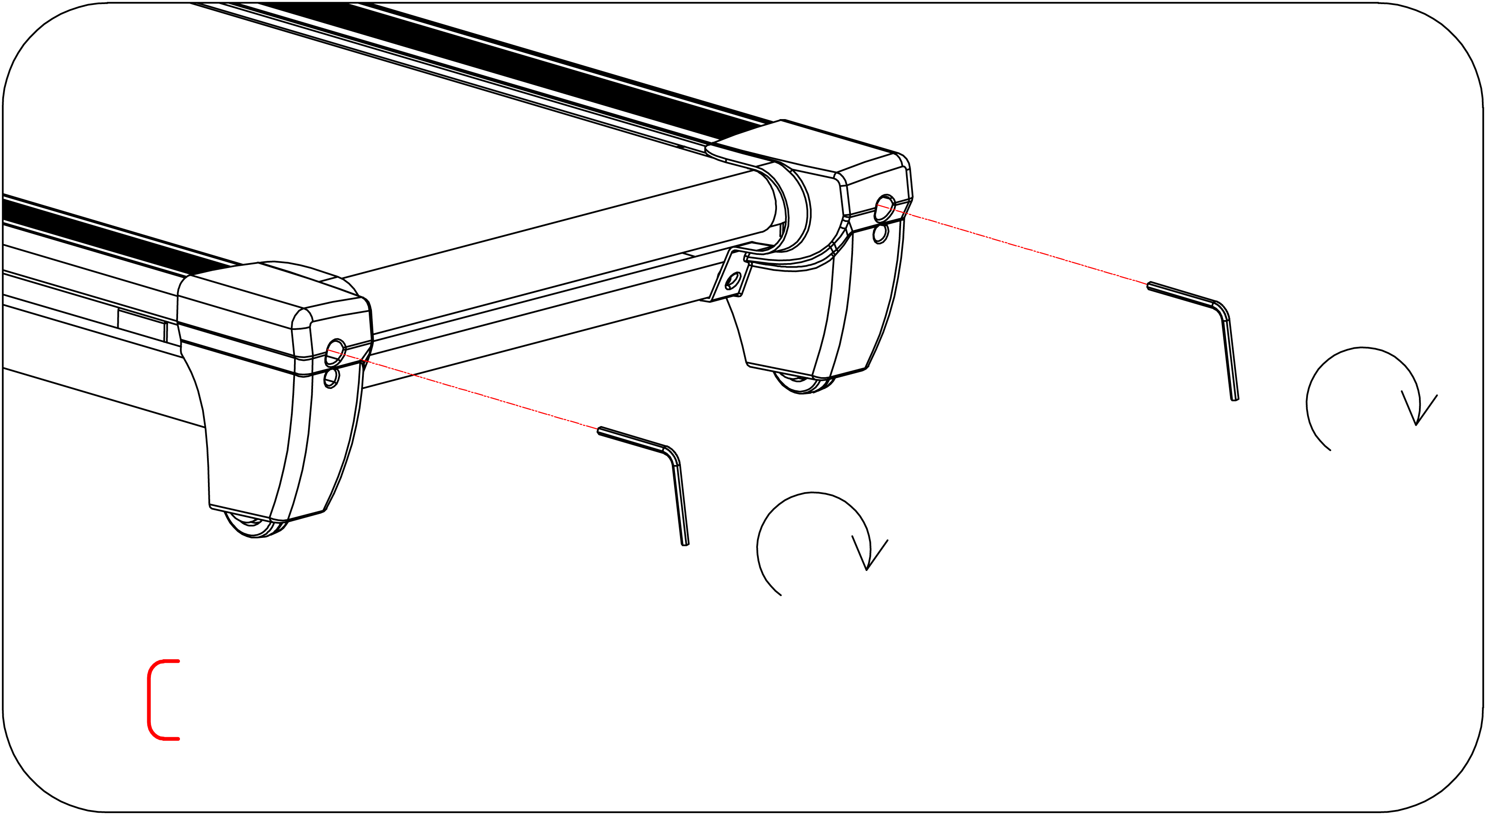
3. Over time the Running Belt will loosen. To tighten the belt turn the Left & Right side adjustment bolts one full turn clockwise, check the tension of the belt. Continue this process until belt is at the correct tension. Make sure to adjust both sides equally to ensure correct belt alignment. Refer to figure C.

LUBRICATING THE TREADMILL

IMPORTANT NOTE:
You will need to lubricate your treadmill before the first use.

RUNNING BELTS & TREADMILL LUBRICANT:
Lubricating the running board and running belt is essential as the friction between the two affects the life span and function of the treadmill, therefore it is suggested that the running board and belt be inspected regularly.

WARNING: Always unplug the treadmill from the electrical outlet before cleaning, lubricating or repairing the unit.

HOW TO LUBRICATE:
1. Raise the belt up on one side and apply lubricant to the running deck. Use a rag to thoroughly wipe the lubricant over the running deck. Repeat this process for the other side.
2. The moving parts should turn freely and quietly. Abnormality of moving parts will affect the safety of the equipment. Inspect and tighten bolts regularly.
3. To better maintain the treadmill and prolong its lifespan, it is suggested that maintenance be done on a regular basis.
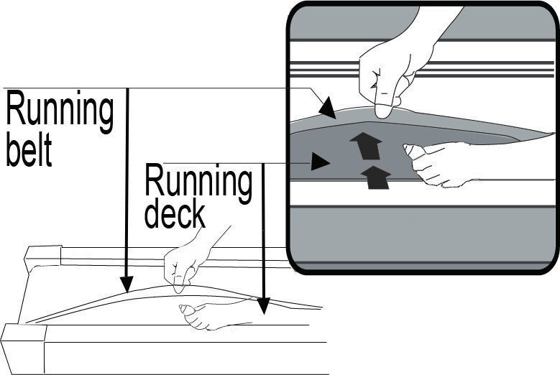

The following time table is recommended:
Light user (less than 3 hours/ week) every six months
Medium user (3-5 hours/ week) every three months
Heavy user (more than 5 hours/ week) every two months

EXPLODED DRAWING

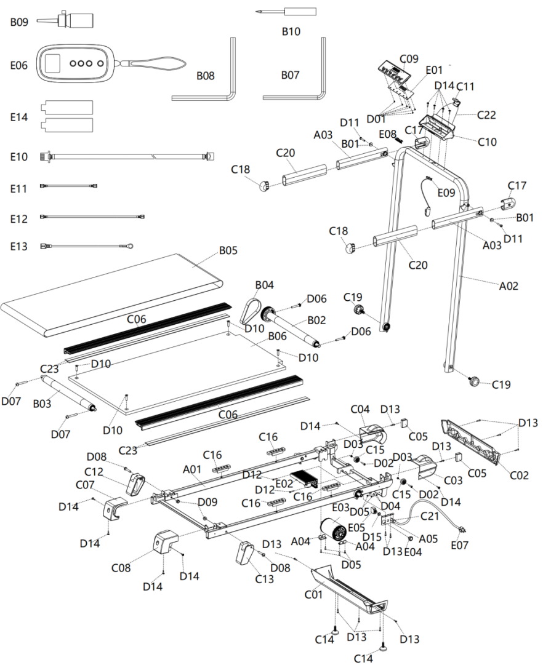

PARTS LIST
No. | Part Description | Remark | qty | No. | Part Description | Remark | qty
A01 | Main Frame |  | 1 | C20 | Handle Bar Foam |  | 2
A02 | Upright Tube |  | 1 | C21 | Power Cable Buckle |  | 1
A03 | Handlebar Tube |  | 2 | C22 | Sprint Rope |  | 1
A04 | Motor Press Piece |  | 2 | C23 | Side Rail Foam |  | 4
A05 | Power Wire Fixing Board |  | 1 | D01 | Screw | ST2.9*6 | 6
B01 | Bearing |  | 2 | D02 | Bolt | M5*25 | 2
B02 | Front Roller |  | 1 | D03 | Nut | M5 | 2
B03 | Back Roller |  | 1 | D04 | Spring Washer | Ф4.3*Ф6.8 | 2
B04 | Motor Belt |  | 1 | D05 | Bolt | M4*12 | 6
B05 | Running Belt |  | 1 | D06 | Bolt | M8*50 | 2
B06 | Running Board |  | 1 | D07 | Bolt | M8*62 | 2
B07 | S5 Allen Wrench |  | 1 | D08 | Bolt | M8*45 | 2
B08 | S6 Allen Wrench |  | 1 | D09 | Nut | M8 | 2
B09 | Lubrication Oil |  | 1 | D10 | Bolt | M8*30 | 4
B10 | Cross Screwdriver |  | 1 | D11 | Bolt | M6*35 | 2
C01 | Motor Bottom Cover |  | 1 | D12 | Screw | ST4.2*25 | 2
C02 | Motor Front Cover |  | 1 | D13 | Screw | ST4.2*19 | 10
C03 | Front Cover (R) |  | 1 | D14 | Screw | ST4.2*19 bigger diameter | 10
C04 | Front Cover (L) |  | 1 | D15 | Flat Washer | Φ12*Φ16 | 1
C05 | Foot Pad |  | 2 | E01 | PCB Board |  | 1
C06 | Side Rail |  | 2 | E02 | Control Board |  | 1
C07 | Back End Cover(L) |  | 1 | E03 | DC Motor |  | 1
C08 | Back End Cover(R) |  | 1 | E04 | Power Switch |  | 1
C09 | Console Cover Upper |  | 1 | E05 | Circuit Breaker |  | 1
C10 | Console Cover Lower |  | 1 | E06 | Remote Control |  | 1
C11 | Device Top Holder |  | 1 | E07 | Power Cable |  | 1
C12 | Leveller (L) |  | 1 | E08 | Safety Key Socket |  | 1
C13 | Leveller (R) |  | 1 | E09 | Safety Key |  | 1
C14 | Foot Pad |  | 2 | E10 | PCB&Control Board Connection Wire |  | 1
C15 | Transport Wheel |  | 2 | E11 | Connection Wire | 120mm | 1
C16 | Cushion |  | 4 | E12 | Connection Wire | 280mm | 1
C17 | Handlebar Front Cover |  | 2 | E13 | Grounding Wire |  | 1
C18 | Handlebar Back Cover |  | 2 | E14 | Remote Control Battery |  | 2
C19 | Knob |  | 2

ONE-YEAR LIMITED WARRANTY
The manufacturer warrants this product against defects in materials and workmanship on functional parts, for a period of 1 year from the original date of purchase. Your sales receipt showing the date of purchase of the product is your proof of purchase. Keep it in a safe place for future reference. This warranty is subject to personal use only, commercial or rental applications will not be covered.
This product is made with the highest quality materials and is warranted to be free from defects in materials and workmanship at the time of purchase. This limited warranty applies to products manufactured or distributed by the manufacturer, are delivered in the continental United States or Canada and extends to the original purchaser, or gift recipient. This warranty becomes valid at the time of purchase and terminates either by the specified time frame listed above and/or owner transfer. Any refunds or monetary compensations must be claimed through the place of purchase (retailer), and not through the manufacturer. Any extended warranties (warranties that cover above and beyond this manufacturer warranty) that are sold through a retailer or third party, are not directly correlated with this products’ limited warranty, and may be redirected to said retailer or third party for coverage.
This warranty extends through the manufacturer of the product, and covers functional parts only. Cosmetics are not covered, unless unequivocally determined it is a workmanship defect. Shipping damage should be addressed with the shipping company, retailer, or place of purchase, not the manufacturer unless the manufacturer was the direct shipper.
The manufacturer’s sole obligation under this warranty shall be limited to furnishing the original purchaser replacement parts for units deemed repairable by the supplier’s warranty department. The purchaser is responsible for insuring any parts shipped or returned, if desired. The purchaser is responsible to prepay any shipping charges (both ways) including, but not limited to taxes and duties. All exchanged parts and products replaced under this warranty will become the property of manufacturer. The manufacturer reserves the right to change manufacturers of replacement parts or products for use, in order to cover any existing warranty.
The purchaser may be asked to provide the supplier with proof of purchase documents (including the date of purchase) if requested. Any evidence of alteration, erasing, or forgery of proof of purchase documents will be just cause to VOID this limited warranty. Products, in which the serial number has been defaced or removed are not eligible for warranty coverage.
This warranty does not apply if the unit has been subject to negligence, fabrication, misuse, abuse, or repairs, alteration by non-manufacturer authorized personnel, inappropriate installations, or any case beyond the control of the manufacturer. Examples of warranty invalidation may also include, but are not limited to:
• Use of lacquer or paints in (and around) the product
• Product placed on non-approved surfaces
• Electrical requirement deficiencies
• Use on extension cords/timers/surge protectors/GFCI
• Outdoor applications
• Normal wear/tear/weathering
• Pet/consumer accidents
• Purchases from dealers unauthorized by the manufacturer (Authorization in writing)
The manufacturer shall not be liable for any loss due to use (or misuse) of the product or other incidental or consequential costs, expense or damages without irrefutable foundations. Under no circumstances shall the manufacturer or any of its representatives be held liable for injury to any person or damage to any property, however arising. Any implied warranty shall have duration equal of the applicable warranty stated above. Specifications are subject to change without notice or obligation.
This limited warranty gives the original purchaser specific legal rights. Other rights may vary from state to state.

编码：
V1.1

