Infrared Sauna

Owners Manual 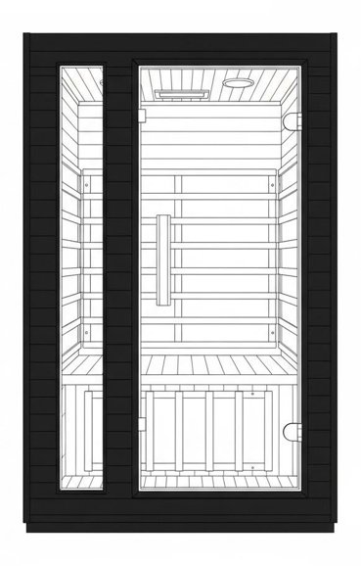
FOR INDOOR USE ONLY
A 120V AC 15 AMP dedicated circuit is required


Questions, problems, missing parts? Contact technical support department at 657-341-0362, 9:00 a.m. - 5 p.m., CST, Monday - Friday or contact us via email at cs@scsources.com.
Please have your model and serial number re
TABLE OF CONTENTS

Welcome…………………………………………………………… 1

Introduction…………………………………………………………… 2

Installation Requirements………………………………………… 3

Safety Warnings…………………………………………………… 4

Assembly Instructions……………………………………………… 6

Precautions…………………………………………………………… 15

Control Panel Operating Instructions……………………………… 17

Troubleshooting……………………………………………………… 19

Cleaning and Maintenance………………………………………… 20

Warranty…………………………………………………………… 21
WELCOME

Thank you for purchasing your ultra low EMF carbon sauna. We appreciate your trust in our product and welcome you to a relaxing wellness experience in the comfort of your home.

Our goal is to design and manufacture high-quality infrared saunas that emphasize craftsmanship, reliability, and user safety. Our growing customer base reflects our commitment to product quality, consistent manufacturing standards, and customer satisfaction.

At our factory, we use carefully selected materials and modern construction methods while adhering to established safety standards. Each sauna is designed for indoor residential use and built to provide a comfortable and enjoyable environment when used as directed.

Please read this owner’s manual thoroughly before installing or using your sauna. Proper installation, use, and maintenance will help ensure safe operation and long-term performance.

INTRODUCTION
Infrared saunas are designed to provide a warm, comfortable environment intended for relaxation and general wellness use. Many users enjoy incorporating sauna sessions into their personal self-care routines in the privacy of their own homes.

Please read this owner’s manual carefully and completely before using your infrared sauna for the first time. Proper use and adherence to the instructions and safety guidelines in this manual will help ensure safe operation and long-term enjoyment of your product. Retain this manual for future reference.

Intended Use & General Wellness Information
This infrared sauna is intended for non-medical, residential use only. Users commonly report feeling relaxed and refreshed after a sauna session. Individual experiences may vary based on personal tolerance, session duration, and environmental conditions.

This product is not a medical device and should not be used as a substitute for medical care, diagnosis, or treatment.

Product Features
High quality craftsmanship
Automatic thermostat for constant temperature
Timer and buzzer: buzzer sounds 5 minutes before the end of session
Digital sensor and thermometer
Ultra Low Carbon heating plate
MP3/AM/FM Car Stereo Speakers with reading Light and LCD Control Panel

Important Health & Safety Disclaimer
The infrared heating elements in this sauna produce heat intended solely for comfort and relaxation. This product does not diagnose, treat, cure, or prevent any disease or medical condition.

If you have a medical condition, are pregnant, are taking prescription medications, or have concerns regarding heat exposure, consult a qualified healthcare professional before using the sauna.

Individuals with surgical implants (such as metal pins, rods, artificial joints, silicone implants, or similar devices) should consult their physician or surgeon prior to use.

Use of this sauna is voluntary and at the user’s own discretion. Always follow the safety instructions provided in this manual.
INSTALLATION REQUIREMENTS

- Dedicated Electrical Outlet
Do not plug any other appliances into the same electrical outlet as your sauna. A dedicated outlet is required for safe operation.
- Level Surface & Clearance
The sauna must be installed on a level, stable surface. Maintain a minimum clearance of 2 inches (5 cm) from all walls to allow for proper ventilation and access.
- Moisture Protection
Do not spray the exterior of the sauna with water. If the installation area floor is damp, use a suitable floor barrier or platform to keep the sauna elevated and dry.
- Fire Safety
Do not store flammable materials, chemicals, or combustible substances near the sauna.
- Indoor, Dry Location Only
The sauna is designed for indoor use only and must be placed in a dry, well-ventilated area. Exposure to moisture may damage both the interior and exterior components.
- Electrical Safety During Installation
Installation and connection of all electrical components (including the control unit and heating elements) must be performed only when the power supply is disconnected.
- Local Code Compliance
Installation must comply with all applicable local building codes and electrical regulations.
- No Extension Cords
Extension cords are not recommended. Plug the sauna directly into a properly rated wall receptacle.
- Technical Support
If you encounter installation issues that are not clearly explained in this manual, contact the manufacturer or authorized technical support before proceeding.

Manufacturer Notice
• The manufacturer reserves the right to change product specifications without notice.
• All illustrations and specifications are provided for reference only and may vary by model.
• Actual product specifications are based on the specific model purchased.

SAFETY WARNINGS
Read all safety instructions before installing or using this sauna. Failure to follow these instructions may result in injury, electrical shock, fire, or damage to the product.

If you are unsure whether sauna use is appropriate for you, consult a qualified healthcare professional before use. If you feel light-headed, dizzy, nauseated, or uncomfortable at any time during a session, exit the sauna immediately.

- This sauna has been manufactured in accordance with applicable safety standards. However, improper installation or use may result in hazards. Always follow the instructions and warnings provided in this manual.
- When installing and using this electrical equipment, basic safety precautions must always be followed.
- Before turning on the sauna, ensure that no objects are placed on or against the heating elements.
- Burn Hazard:
The infrared heating panels become hot during operation.
• Do not touch the heating elements while the sauna is operating.
• Allow the sauna to cool completely before cleaning or servicing.
- This sauna is not intended for use by children under 8 years of age.
- Children 8 years of age and older, and individuals with limited physical, sensory, or mental capabilities, or lack of experience or knowledge, may use the sauna only under continuous supervision and after receiving proper instruction on safe use.
- Children must not play in or around the sauna.
- Children under 14 years of age may clean the sauna only when supervised.
- Do not use the sauna immediately after strenuous exercise. Allow at least 30 minutes for the body to cool down before entering.
- Overheating Risk:
Prolonged exposure to high temperatures may cause overheating. Symptoms may include dizziness, weakness, nausea, drowsiness, or fainting.
• Always limit session duration based on personal comfort.
• Exit the sauna immediately if any discomfort occurs.
- Pregnant or possibly pregnant individuals should consult a healthcare professional before using the sauna, as elevated temperatures may pose risks during pregnancy.
- Do not use the sauna while under the influence of alcohol, drugs, or medications that may impair alertness
or affect heart rate, blood pressure, or circulation.
- Individuals with medical conditions such as heart disease, high or low blood pressure, circulatory conditions, diabetes, or other chronic conditions should consult a healthcare professional before use.
- If you intend to use the sauna for any medical or therapeutic purpose, consult a qualified healthcare
professional prior to use. This sauna is not a medical device.
- Never sleep inside the sauna while it is in operation.
- Do not use cleaning agents on the interior surfaces of the sauna unless specifically recommended in this
manual.
- Do not place, stack, or store objects on top of or inside the sauna.
- If the power supply cord becomes damaged, it must be replaced only by the manufacturer, an authorized
service provider, or a similarly qualified technician to avoid risk of injury or hazard.
- Do not use the sauna during an electrical storm due to the potential risk of electrical shock.
- For added protection during thunderstorms, or when the sauna will be unused for extended
periods, unplug the power cord from the wall outlet.
- Do not alter or tamper with any electrical connections. Doing so will void the manufacturer’s warranty and
may create a safety hazard.
- Always dry your hands before operating electrical controls.
• Never unplug the power cord or adjust controls with wet hands or while standing barefoot on a wet
surface.
- Do not attempt repairs without first consulting the manufacturer or authorized service provider.
Unauthorized repairs will void the warranty.
- Route the power supply cord so it is not likely to be walked on, pinched, or damaged by furniture or other
objects.
- Do not overload wall outlets or extension cords, as this may result in fire or electrical shock.
- Always disconnect the sauna from the power source before cleaning or servicing.
- Do not remove power supply covers. There are no user-serviceable parts inside.
- If you feel uncomfortable or overheated during a session, lower the temperature, open the door, or exit the
sauna immediately.
- To avoid fire, do not dry clothes or leave any towels in the sauna.
- To prevent burns or electric shocks, do not touch or use metal tools on the net cover of the Ultra Low Carbon heater elements.
- While in the sauna, do not touch the light bulb. If the bulb needs to be changed, switch it off and wait until the sauna is shut off and the bulb is cool
- Do not spray water on the Ultra Low Carbon Heater. This activity may result in electric shock or damage to the heater elements
- Do not use the infrared low EMF carbon sauna if you have any of the following conditions:
- Open wounds
- Eye diseases
- Sever sunburns
- Elderly & weak people, especially those suffering from a disease, pregnant women and infants are prohibited. Children over the age of 6 years may use the sauna under the supervision of adults.
- If suffering from a disease directly related to temperature, seek the advice of a doctor before using.
- Do not place pets in the sauna.
- Do not use the sauna if you are under the effects of alcohol.

ASSEMBLY INSTRUCTIONS
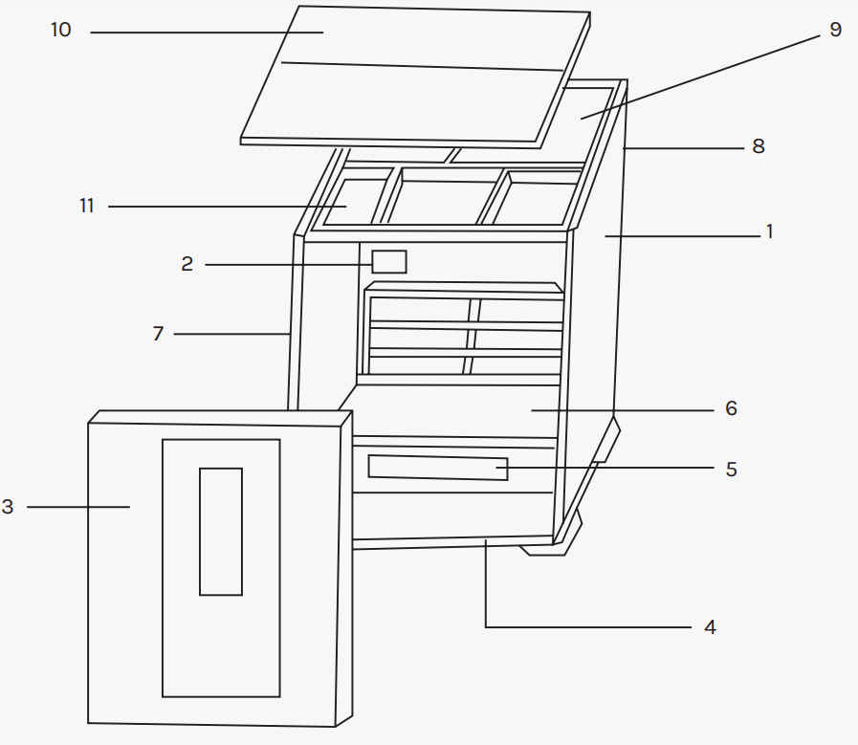
FIG-1

S/N | PART NO. | PART DESCRIPTION | QTY
1 | KDZP01 | Right Side Panel | 1
2 | KDZP02 | LCD Display | 1
3 | KDZP03 | Front Panel | 1
4 | KDZP04 | Bottom Panel | 1
5 | KDZP05 | Bench Support | 1
6 | KDZP06 | Sitting Bench | 1
7 | KDZP07 | Left Side Panel | 1
8 | KDZP08 | Back Panel | 1
9 | KDZP09 | Internal Top Panel | 1
10 | KDZP10 | Top Panel Cover | 1
11 | KDZP11 | Electric Control Box | 1

1. Place the bottom panel (Sauna room diagram,) in the desired location of your sauna and make sure which side is the front and which side is the back. See FIG-3.
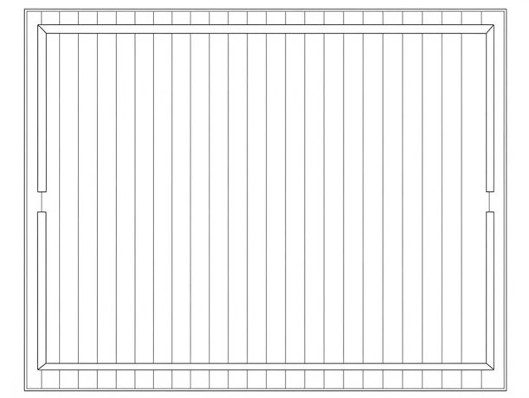
FIG-3 Placing bottom floor

- Align the back panel (section 8) with bottom panel’s corresponding battens; make sure they are in line. See FIG-4, Connect the bottom heater element wire to corresponding wire from the back panel.
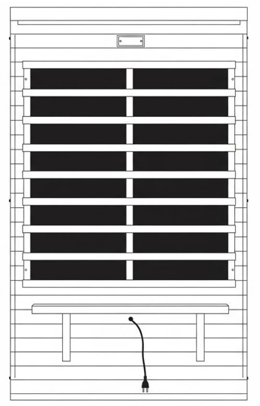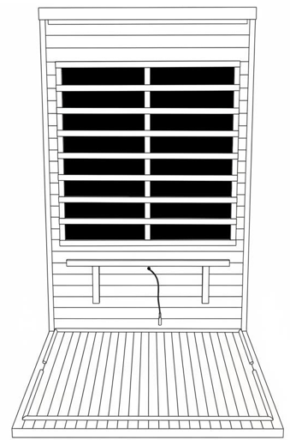
FIG-4 Back Panel FIG-5 Assembling back panel

- Align the left Panel (section 7) with bottom Panel’s corresponding battens; make sure left Panel fits flush into back Panel. See FIG-6&7

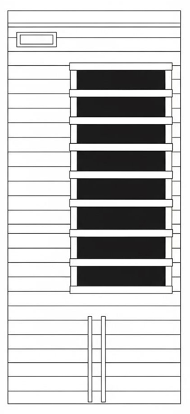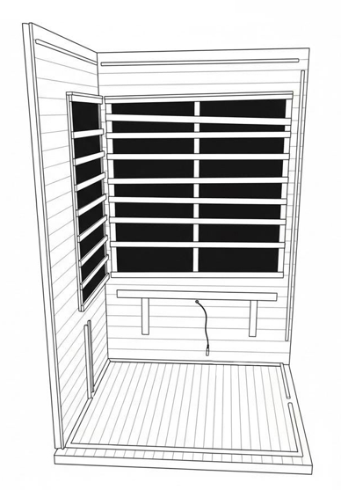
FIG-6 Right Panel FIG-7 Assembling right panel

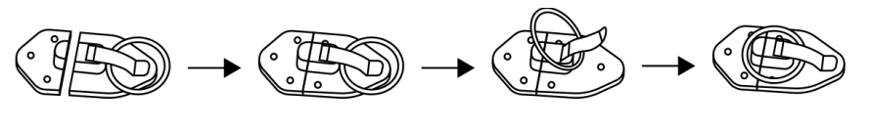
FIG-8 (Combination to assembly) Buckle

- The latch has a guide tab that must be placed in the guide slot for alignment. Pick up the back panel (hold it upright to the floor panel) and place the tab in the slot, do not latch at this time. When the back wall and the front wall/side wall are set together on the floor panel, close and pin the latches. See Figure 8

- Align the right Panel (section 1) with bottom Panel’s corresponding battens; make sure right Panel fits flush into Back Panel and latch together. See FIG-9&10

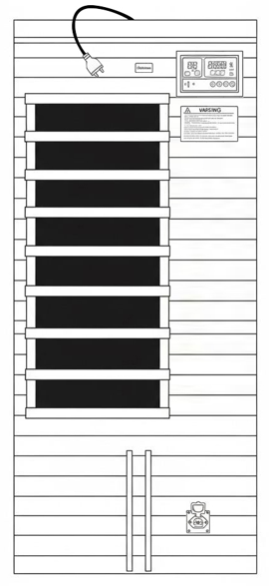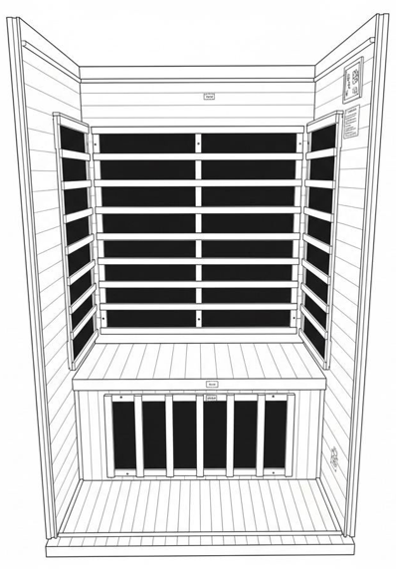
FIG-9 Right Panel FIG-10 Assembling right panel

*The right side panel is equipped with a pre-installed power interface for medical-grade red light therapy panel.
.

- *First, vertically insert the bench's support plate with the carbon plate into the slot and connect the power cable. Then, horizontally insert the bench's surface panel into the slot. See FIG-11

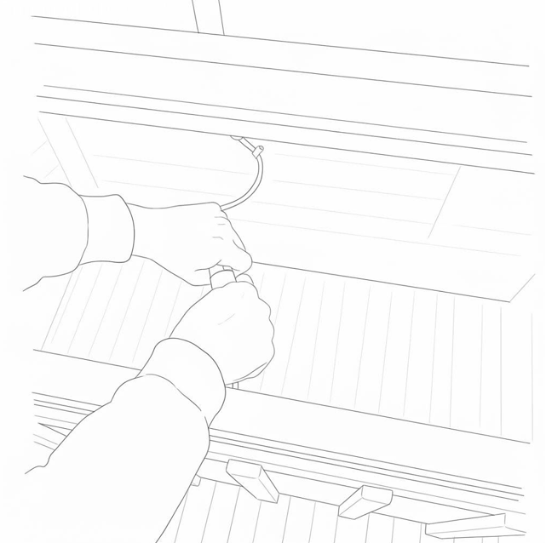
FIG-11

- Then, horizontally insert the bench's surface panel into the slot. See FIG-12&13
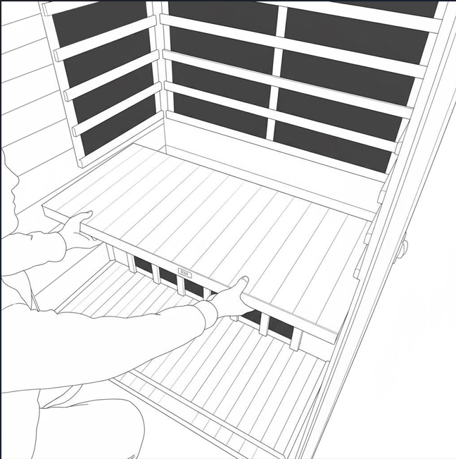
FIG-11 Bench Support FIG-12 Assembling Bench

- Align the Front Panel (section 3) with Bottom Panel’s corresponding battens and then latch it with the Left and Right Panels respectively. Notes: Take caution of the glass door to avoid damage. See FIG-13&14
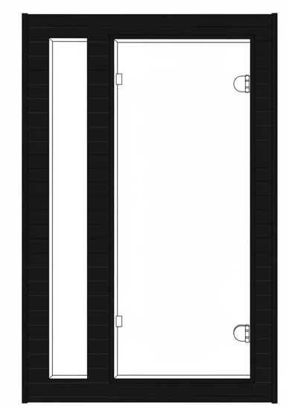
FIG-13 front Panel FIG-14 Assembling front Panel

- Put all the wires outside to leave enough space for setting up the top Panel (section 9). Open the door, raise the top Panel high enough to see if it fits with the surrounding Panels, then put down. See FIG-15&16

- While putting down the internal Top Panel, make sure all the wires (mentioned above) and connecting plugs are slipped through the corresponding holes of the Top Panel.
See FIG-17 All these wires will be led into connecting with the controller on the internal top Panel. FIG-18

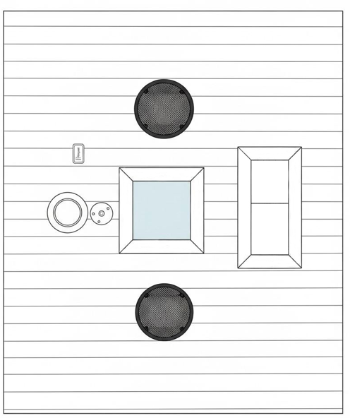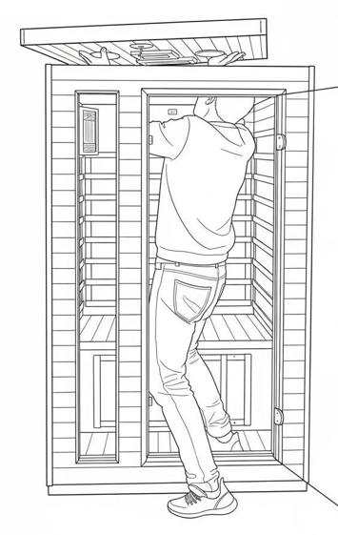
See FIG-15 Top panel See FIG-16 Assembling Top Panel
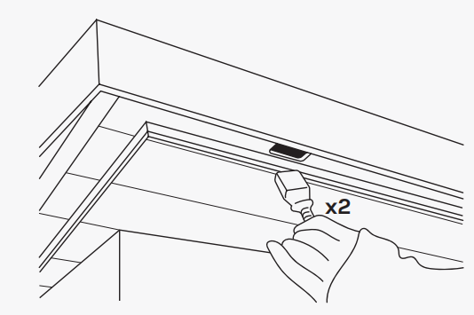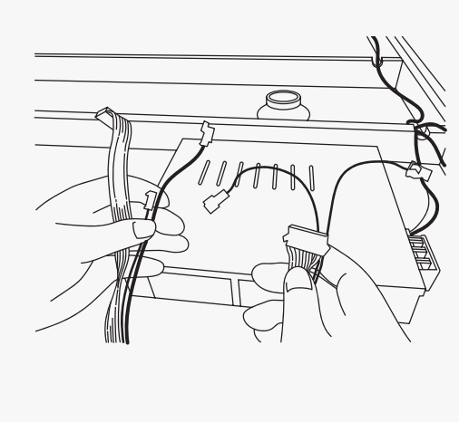
FIG-17 FIG-18

See FIG-17 Leading the wires of heaters onto the Panel through the corresponding hole(If applicable)

See FIG-18 Put down the power plugs of the speakers, temperature sensor, control panel through the hole on the top Panel

- All the ultra low carbon heaters are pre-assembled. Connect all the wires and connectors to the corresponding outlets on the Top Panel. Please be sure all the plugs are connected tightly in case of outlet damage. See FIG-19

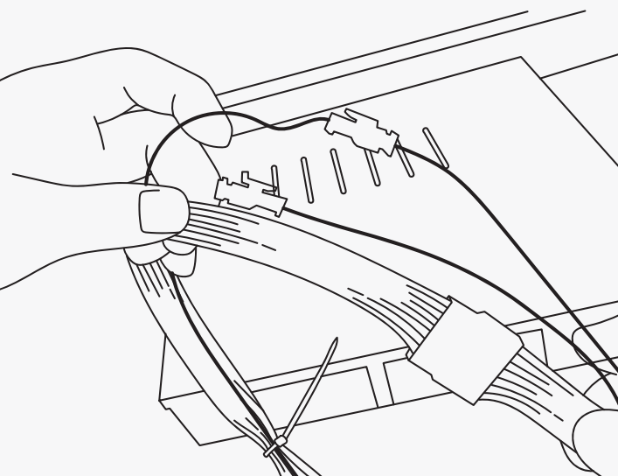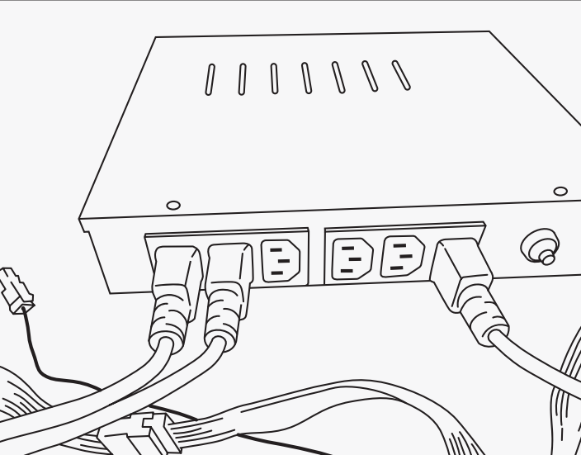
FIG-19 Connectors on the internal top Panel FIG-20 Compress and tuck wires neatly

- All the wiring from top Panel should be linked with corresponding connectors of the control panel, the temperature sensor and the radio antenna. Otherwise, the sauna will not function if any connections are missed. See FIG-20

- Making sure all steps are finished correctly, plug in the power and try using the sauna at first to make sure it will work properly. Then put the external top Panel (section 10) over the internal Top Panel and put out the power plug through the corresponding hole in the external top Panel. See FIG-21
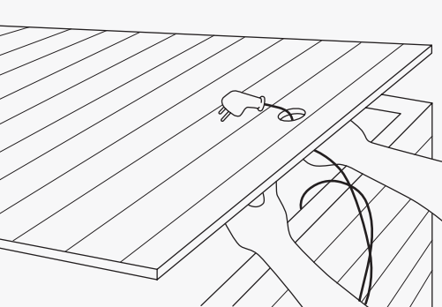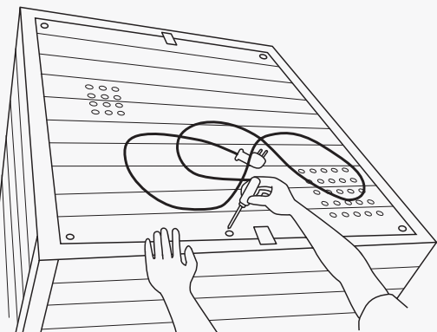
FIG-21 Slip the power plug through external top Panel FIG-22 Fix the external Panel with screws

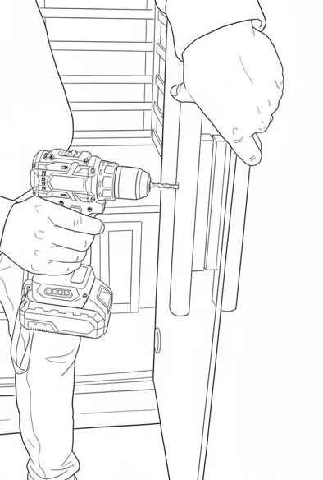
FIG-23 Installing the door handle

- Take the screws affixed on the external top Panel, then set up the Panel using the cross screwdriver. See FIG-22

- Pls installing the door handle, towel rack, and the cup holder (Oxygen Ionizer if configured)
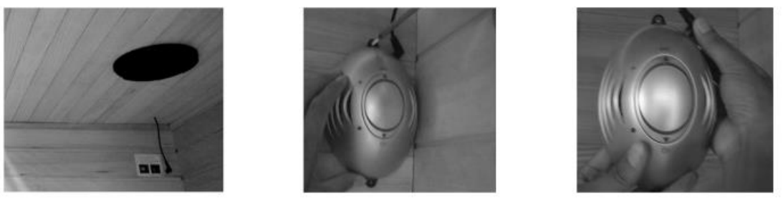

PRECAUTIONS
The following precautions are intended to help you use your infrared sauna safely, comfortably, and responsibly. Always listen to your body and adjust use based on personal comfort.

1. Electrical & Setup Safety
• Verify that all wiring, circuitry, and the power plug meet local electrical requirements before use.
• Only plug the sauna into a dedicated 110–120V grounded wall outlet. Do not share the outlet with other appliances.
• Always unplug the sauna when not in use.
• Do not use extension cords or power strips.
• Do not operate the sauna if the power cord or plug is damaged.

2. General Use Safety
• Set the temperature and session time to a comfortable level before entering.
• Drink water before, during, and after sauna use to help maintain normal hydration.
• To avoid burns, do not touch the heating elements while the sauna is operating.
• If the sauna feels too warm or stuffy, open the roof vent or partially open the door to regulate airflow.
• After your session, turn the sauna off and unplug the power cable.
• After 2 hours of continuous operation, allow the sauna to cool down for at least 1 hour before resuming use.

3. Temperature & Time Controls
• Use the temperature buttons to increase or decrease heat in small increments.
• Holding the “+” or “–” button for several seconds will adjust settings more quickly.
• The indicator light will turn off once the selected temperature is reached.
• Set the session timer using the function and “+ / –” buttons (5–90 minutes).
• When the timer reaches the final 5 minutes, an alert will sound. The sauna will shut off automatically after the countdown unless the timer is reset.

4. Personal Comfort & Body Awareness
• Use towels for comfort and cleanliness:
• Sit on a folded towel and place one on the floor to absorb moisture
• Keep an extra towel available to wipe perspiration
• Wipe away perspiration as needed to remain comfortable.
• Light stretching or gentle movement may be performed. Avoid sudden movements.
• Cover hair with a towel if desired. Rinse hair after use if products were applied.
• Avoid applying lotions, oils, or cosmetics before or during sauna use, as they may affect the skin’s response to heat.
• Avoid heavy meals immediately before use. Many users find sauna sessions more comfortable on a light or empty stomach.
5. Cooling & After Use
• If additional cooling is needed during use, open the door until the temperature feels comfortable.
• After a session, allow your body to cool gradually. Sitting with the door partially open for a few minutes may feel more comfortable.
• Once comfortable, a warm or cool shower may be taken to rinse perspiration from the body.
• If you feel dizzy, lightheaded, or uncomfortable at any time, end the session immediately.

6. Moisture & Care
• If showering before a session, dry off completely before entering the sauna to prevent excess moisture from contacting the wood.
• Keep liquids away from control panels and electrical components.

7. Electronic Devices
If using personal electronic devices (such as phones or audio players) inside the sauna:
• Limit usage time
• Remove the device immediately if it becomes warm
• Follow the device manufacturer’s temperature and safety guidelines
• The sauna manufacturer is not responsible for damage to personal devices

⚠️ Important Notice
This sauna is intended for relaxation and personal wellness use only. It is not a medical device. Any temperature, time, or comfort recommendations are general in nature and should be adjusted based on individual tolerance.

CONTROL PANEL
*** Do not leave the sauna or Music player on for more than 2 hours at a time. ***
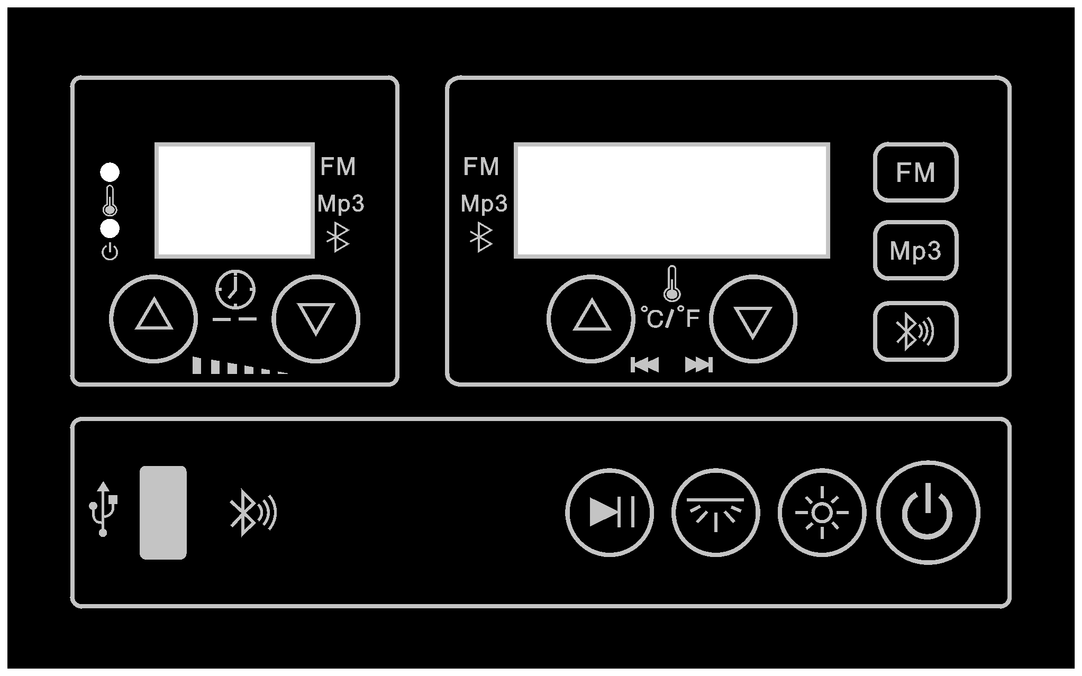

Button | Function | Description
Power | Power ON / OFF | Press to turn the sauna ON or OFF. When powered on, the display shows the last used temperature and time settings. When powered off, the unit enters standby mode and the power indicator light flashes.
▲ / ▼ (Temperature Up / Down) | Temperature Adjustment | Press ▲ to increase or ▼ to decrease the temperature. Hold the button for continuous adjustment. After about 5 seconds of inactivity, the display returns to the current temperature.
⏱ ▲ / ▼ (Time Up / Down) | Session Time Adjustment | Press ▲ or ▼ to set the session time (5–90 minutes). Hold to adjust more quickly. When the timer reaches 00, heating stops and an audible alert sounds.
▲ + ▼ (Pressed Together) | °F / °C Toggle | Press and hold both ▲ and ▼ simultaneously while setting temperature to switch between Fahrenheit and Celsius.
💡 (Light) | Reading Light | Press once to turn the interior reading light ON. Press again to turn it OFF. The light can be operated even when the sauna is powered off.
🌈 (Color Light) | Color Therapy Lighting | Color lighting turns on automatically when the sauna is powered on. Press to cycle through colors: white, red, green, blue, yellow, purple, auto, and off.
FM | FM Radio Mode | Press once to enter FM radio mode. The display shows the current station. Frequency range: 76.0–108.0 MHz.
▲ / ▼ (FM Mode – Right Side) | FM Station Selection | Press ▲ or ▼ to search for radio stations. The frequency briefly displays, then returns to temperature/time.
▲ / ▼ (FM Mode – Left Side) | Audio Volume | Press ▲ to increase or ▼ to decrease the audio volume.
⏯ (Play / Pause) | Audio Control | Press to play or pause FM radio or MP3 audio playback.
MP3 | MP3 / Bluetooth Audio Mode | Press twice to enter MP3 mode. The display shows the current track.
▲ / ▼ (MP3 Mode – Right Side) | Track Selection | Press ▲ or ▼ to skip to the previous or next track.
▲ / ▼ (MP3 Mode – Left Side) | Audio Volume | Press ▲ to increase or ▼ to decrease the volume during MP3 playback.
🔊📶 (Bluetooth) | Bluetooth Audio Mode | Press the Bluetooth button three times to enter Bluetooth mode. The display will show “B-” and a confirmation tone will sound. On your mobile device, search for and connect to the sauna’s Bluetooth name. Once connected, audio from your device will play through the sauna speakers. Use ▲/▼ buttons to adjust volume and the ⏯ button to play or pause audio.

Important Operating Notes
• Automatic Display Return: If no buttons are pressed for approximately 5 seconds, the display automatically returns to showing the current temperature and remaining session time.
• Timer Countdown to “00”: When the session timer counts down to “00”, the heaters will stop automatically.
• Buzzer Reminder: When the timer reaches “00,” an audible buzzer will sound five times to alert the user that the session has ended.
• Timer Reset: To continue using the sauna after the timer reaches “00,” reset the session time using the Time ▲/▼ buttons.
• Bluetooth Mode: Press the Bluetooth button three times to enter Bluetooth audio mode. The display will show “B-” and a confirmation tone will sound.
• Bluetooth Range: The effective Bluetooth operating range is approximately 10 meters (33 ft).
• Bluetooth Reconnection: If audio does not play after pairing, turn Bluetooth off on your mobile device, unplug the sauna, then reconnect power and pair again.
• Audio Volume Control: Volume can be adjusted using the ▲/▼ buttons while in FM, MP3, or Bluetooth audio modes.
• Lighting Control: Interior lighting can be turned on or off using the Light button, even when the sauna is powered off.
• Color Light Behavior: Color lighting turns on automatically when the sauna is powered on and can be cycled through available colors using the Color Light button.• Temperature Unit Setting: Temperature units (°F / °C) can be switched by pressing and holding the ▲ and ▼ temperature buttons simultaneously while adjusting temperature.
• Power Memory: When powered on, the sauna displays the last used temperature and time settings.
• Standby Indicator: When the sauna is plugged in but powered off, the power indicator light will flash to indicate standby mode.

TROUBLESHOOTING
 | PROBLEMS | EXPLANATION | SOLUTIONS
1 | Indicator light for power supply not working | The socket can’t work properly | Check the power supply and  socket, or replace a new one
1 | Indicator light for power supply not working | The fuse is burned out | Change the fuse
2 | Indicator light for function is not working | The corresponding indicator light is broken | Repair or replace the relevant control panel
2 | Indicator light for function is not working | The circuit or some accessories are broken for relevant functions | Repair or replace the circuit for corresponding functions
3 | Ultra Low Carbon Heater can’t work to produce heat and Ultra Low Carbon ray | The heater is broken | Replace with a new one  Of the same specifications
3 |  | Its life will be shorted gradually for being used for many times | Replace with a new one  Of the same specifications
3 |  | The fuse is burned out | Replace with a new one of the same specifications
3 |  | The circuit connection for the heater is wrong | Check it, and reconnect them tightly
3 |  | The circuit for corresponding control panel or accessories is broken | Repair or replace it
4 | The abnormal temperature inside the entire body of Ultra Low Carbon sauna room | Some problems with heater | See the 3rd items
4 |  | Wrong operation for setting | Reset it
4 |  | The circuit for temperature controlling or some accessories are broken | Repair it or replace the control panel
5 | Light. Peculiar smell. Allophone appear inside sauna body | The circuit problems (broken accessories, short circuit, failure for controlling system) cause the burning of some accessories and electrical controlling center | 1) Cut off the power, check the power supply and voltage;  2) Find the objects with problems  3) Solve the problems
6 | The light not working | The bulb filament is burned out | Replace the bulb
6 | The light not working | The bulb and the lamp fixture are loose | Replace the bulb and raise the reed at the middle of the lamp fixture, screw in the bulb again and reconnect them well
6 | The light not working | The socket is broken | Replace it
6 | The light not working | Problems with electrical control panel | Repair or replace it
7 | Cannot hear sound from the speakers. | The speaker is broken | Replace with a new one of the same specifications
7 | Cannot hear sound from the speakers. | The electrical connection is loose | Reconnect and insert the electrical connection

CLEANING AND MAINTENANCE
1. Natural Wood Characteristics
Your sauna is constructed from natural wood. Variations in color, grain, knots, minor cracks, or natural oil markings are normal characteristics of wood and reflect its natural appearance. These variations are not considered defects.

2. Initial Cleaning
Before using the sauna for the first time, wipe the interior surfaces with a clean, damp cloth.

3. Natural Wood Aroma
The interior wood may produce a natural aroma, especially during the first few months of use. If the scent is noticeable, gently wipe the interior wood surfaces with a damp cloth to help reduce the aroma.

4. Exterior Cleaning
Clean the exterior surfaces using a soft cloth. A furniture-safe polish may be used on exterior wood surfaces only.

5. Use of Towels
To help absorb moisture and maintain cleanliness, place a soft towel on the bench and floor during sauna use.

6. Minor Surface Marks
Light scratches or surface marks may be reduced by gently sanding the affected area with fine-grit sandpaper, sanding in the direction of the wood grain.

7. Cleaning Restrictions
Do not clean the sauna using steam cleaners, high-pressure washers, or by splashing water on any part of the unit. Do no use benzene, alcohol, or strong cleaning chemicals.

8. Wood Texture Changes
In humid conditions, the wood surface may feel slightly rough. If this occurs, lightly smooth the area using fine-grit sandpaper or a non-abrasive sanding sponge, always following the direction of the grain.

9. Seasonal Wood Movement
Natural wood may experience minor cracking, warping, or natural oil markings due to seasonal changes in humidity. This is a natural characteristic of wood and does not indicate a material defect. Do not store in damp environments.

One-Year Limited Warranty

The manufacturer warrants this product against defects in materials and workmanship on functional parts only, for a period of 1 year from the original date of purchase. Your sales receipt showing the date of purchase of the product is your proof of purchase. Keep it in a safe place for future reference. This warranty is subject to personal use only, commercial or rental applications will not be covered. Continuous operating exceeding 3,000 hours will also void the warranty.

This product is made with the highest quality materials and is warranted to be free from defects in materials and workmanship at the time of purchase. This limited warranty applies to products manufactured or distributed by the manufacturer, are delivered in the continental United States or Canada and extends to the original purchaser, or gift recipient. This warranty becomes valid at the time of purchase and terminates either by the specified time frame listed above and/or owner transfer. Any refunds or monetary compensations must be claimed through the place of purchase (retailer), and not through the manufacturer. Any extended warranties (warranties that cover above and beyond this manufacturer warranty) that are sold through a retailer or third party, are not directly correlated with this products’ limited warranty, and may be redirected to said retailer or third party for coverage.

This warranty extends through the manufacturer of the product and covers functional parts only. Cosmetics are not covered, unless unequivocally determined it is a workmanship defect. Shipping damage should be addressed with the shipping company, retailer, or place of purchase, not the manufacturer unless the manufacturer was the direct shipper.

The manufacturer’s sole obligation under this warranty shall be limited to furnishing the original purchaser replacement parts for units deemed repairable by the supplier’s warranty department. The purchaser is responsible for ensuring any parts shipped or returned, if desired. The purchaser is responsible to prepay any shipping charges (both ways) including but not limited to taxes and duties. All exchanged parts and products replaced under this warranty will become the property of manufacturer. The manufacturer reserves the right to change manufacturers of replacement parts or products for use, to cover any existing warranty.
The purchaser may be asked to provide the supplier with proof of purchase documents (including the date of purchase) if requested. Any evidence of alteration, erasing, or forgery of proof of purchase documents will be just cause to VOID this limited warranty. Products, in which the serial number has been defaced or removed are not eligible for warranty coverage.

This warranty does not apply if the unit has been subject to negligence, fabrication, misuse, abuse, or repairs, alteration by non-manufacturer authorized personnel, inappropriate installations, or any case beyond the control of the manufacturer. Examples of warranty invalidation may also include, but are not limited to:

• Use of lacquer or paints in (and around) the product.
• Product placed on non-approved surfaces
• Electrical requirement deficiencies
• Use of extension cords/timers/surge protectors/GFCI
• Outdoor applications
• Normal wear/tear/weathering
• Pet/consumer accidents
• Purchases from dealers unauthorized by the manufacturer (Authorization in writing)

The manufacturer shall not be liable for any loss due to use (or misuse) of the product or other incidental or consequential costs, expense or damages without irrefutable foundations. Under no circumstances shall the manufacturer or any of its representatives be held liable for injury to any person or damage to any property, however arising. Any implied warranty shall have duration equal of the applicable warranty stated above. Specifications are subject to change without notice or obligation.
This limited warranty gives the original purchaser specific legal rights. Other rights may vary from state to state.

