Infrared Sauna

Owners Manual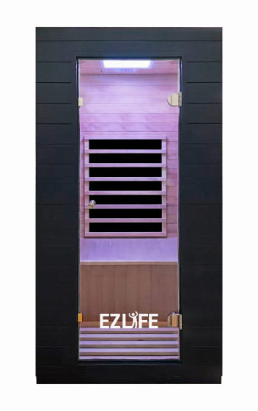

FOR INDOOR USE ONLY
A 120V AC 15 AMP dedicated circuit is required


Questions, problems, missing parts? Contact technical support department at 657-341-0362, 9:00 a.m. - 5 p.m., CST, Monday - Friday or contact us via email at cs@scsources.com.
Please have your model and serial number ready
Index

Page

Welcome 1

Introduction 2

Parts List 3

Installation Requirements 4

Assembly Instructions 5

Digital Control Panel Operating Instructions 10

Recommendations for Operation 12

Recommendation for Use 13

Safety 14

Important Safeguards for Your Sauna 16

Cleaning and Maintenance 17

Troubleshooting 18

Warranty 20

Welcome

Thank you for purchasing your infrared sauna. We appreciate your trust in our product and welcome you to a relaxing wellness experience in the comfort of your home.

Our goal is to design and manufacture high-quality infrared saunas that emphasize craftsmanship, reliability, and user safety. Our growing customer base reflects our commitment to product quality, consistent manufacturing standards, and customer satisfaction.

At our factory, we use carefully selected materials and modern construction methods while adhering to established safety standards. Each sauna is designed for indoor residential use and built to provide a comfortable and enjoyable environment when used as directed.

Please read this owner’s manual thoroughly before installing or using your sauna. Proper installation, use, and maintenance will help ensure safe operation and long-term performance.

Introduction

Infrared saunas are designed to provide a warm, comfortable environment intended for relaxation and general wellness use. Many users enjoy incorporating sauna sessions into their personal self-care routines in the privacy of their own homes.

Please read this owner’s manual carefully and completely before using your infrared sauna for the first time. Proper use and adherence to the instructions and safety guidelines in this manual will help ensure safe operation and long-term enjoyment of your product. Retain this manual for future reference.

Intended Use & General Wellness Information
This infrared sauna is intended for non-medical, residential use only. Users commonly report feeling relaxed and refreshed after a sauna session. Individual experiences may vary based on personal tolerance, session duration, and environmental conditions.

This product is not a medical device and should not be used as a substitute for medical care, diagnosis, or treatment.

Product Features
• Wood construction
• Digital control system with easy-to-use control panel
• Pre-assembled panels with integrated electrical components for simplified installation
• Temperature monitoring sensor
• Energy-efficient operation
• Interior reading light
• Thoughtfully designed details for user comfort

Important Health & Safety Disclaimer
The infrared heating elements in this sauna produce heat intended solely for comfort and relaxation. This product does not diagnose, treat, cure, or prevent any disease or medical condition.

If you have a medical condition, are pregnant, are taking prescription medications, or have concerns regarding heat exposure, consult a qualified healthcare professional before using the sauna.

Individuals with surgical implants (such as metal pins, rods, artificial joints, silicone implants, or similar devices) should consult their physician or surgeon prior to use.

Use of this sauna is voluntary and at the user’s own discretion. Always follow the safety instructions provided in this manual.

Parts list

HY-CH3-1100A
S/N | PART NO. | PART DESCRIPTION | QTYS NOTE
1 | HY001 | Front panel | 1
2 | HY002 | Back panel | 1
3 | HY003 | Side panel (L) | 1
4 | HY004 | Side panel (R) | 1
5 | HY005 | Floor panel | 1
6 | HY006 | Bench heater panel | 1
7 | HY007 | Bench | 1
8 | HY008 | Roof panel | 1
9 | HY009 | Roof cover | 1
10 | HY010 | Heat panel for left side panel | 1
11 | HY011 | Heat panel for back panel | 1
12 | HY012 | Heat panel for right side panel | 1
13 | HY013 | Heat panel for floor panel | 1
14 | HY014 | Heat panel for bench heater panel | 1
15 | HY015 | Hinges | 2
16 | HY016 | Glass door | 1
17 | HY017 | Handle | 2 | Interior & Exterior
18 | HY018 | Control panel | 1
19 | HY019 | Control box | 1
20 | HY020 | Light | 1
21 | HY021 | Bluetooth | 1
22 | HY022 | Speaker | 2
23 | HY023 | Cup holder | 1
24 | HY024 | Screws: For the bench | 2 | M4*30
25 | HY025 | Screws: For the roof panel | 4 | M4*40
26 | HY026 | Screws: For the roof cover | 18 | M3*14

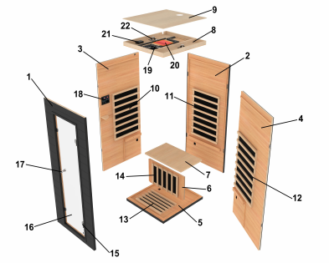
23

Installation Requirements

- Dedicated Electrical Outlet
Do not plug any other appliances into the same electrical outlet as your sauna. A dedicated outlet is required for safe operation.
- Level Surface & Clearance
The sauna must be installed on a level, stable surface. Maintain a minimum clearance of 2 inches (5 cm) from all walls to allow for proper ventilation and access.
- Moisture Protection
Do not spray the exterior of the sauna with water. If the installation area floor is damp, use a suitable floor barrier or platform to keep the sauna elevated and dry.
- Fire Safety
Do not store flammable materials, chemicals, or combustible substances near the sauna.
- Indoor, Dry Location Only
The sauna is designed for indoor use only and must be placed in a dry, well-ventilated area. Exposure to moisture may damage both the interior and exterior components.
- Electrical Safety During Installation
Installation and connection of all electrical components (including the control unit and heating elements) must be performed only when the power supply is disconnected.
- Local Code Compliance
Installation must comply with all applicable local building codes and electrical regulations.
- No Extension Cords
Extension cords are not recommended. Plug the sauna directly into a properly rated wall receptacle.
- Technical Support
If you encounter installation issues that are not clearly explained in this manual, contact the manufacturer or authorized technical support before proceeding.

Manufacturer Notice
- The manufacturer reserves the right to change product specifications without notice.
- All illustrations and specifications are provided for reference only and may vary by model.
- Actual product specifications are based on the specific model purchased.

Assembly Instructions

Assembly requires at least two adults. Read all instructions carefully before beginning and during assembly to ensure proper installation and to prevent damage to the sauna or injury.

Do not connect the sauna to a power source until assembly is complete

<1>LOCATION OF SAUNA
Before assembling the sauna, select an appropriate installation location.
• Ensure the main power cord is easily accessible at all times.
• The installation surface must be dry, level, and stable.

<2>PLACING BOTTOM PANEL

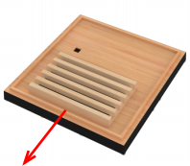
Front

Place the bottom panel flat on the floor in the selected location.
• Ensure the panel is oriented correctly with the FRONT facing forward, as indicated on the panel.
• Confirm the panel is level before continuing.

<3> CONNECTING THE BACK PANEL TO BOTTOM PANEL
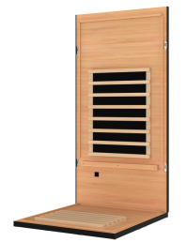
Carefully position the back panel onto the bottom panel by aligning it with the corresponding guides.
• Hold the back panel upright during this step.
• Do not release the back panel until at least one side panel has been installed to provide stability.

<4>CONNECTING THE LEFT SIDE PANEL TO THE BACK PANEL
Align the left side panel with the corresponding interior latches on the back panel.
• Carefully position the panel so the latches align properly.
• Press the panel firmly into place until all latches are fully engaged and secure.
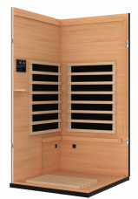
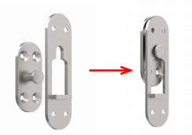

<5>INSTALLING THE BENCH HEATER
Slide the bench heater panel downward by aligning its sides with the vertical guide rails on the side panels.
1. Ensure the heater grille is facing outward toward the interior of the sauna.
2. Lower the bench heater panel completely until it rests on the bottom panel and is securely seated.
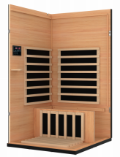
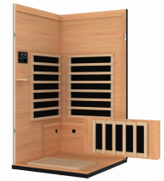

<6>CONNECT THE WIRES UNDER THE BENCH
Connect the four wires from the bench heater, floor heater, right side panel heater and back panel heater to the back panel.
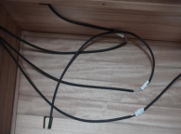
Ensure each connector is matched according to the corresponding label (B to B, C to C, D to D, and E to E). Push each connector firmly together until fully seated

<7>INSTALLING THE RIGHT SIDE PANEL
Align the right side panel with the corresponding interior latches on the back panel. Carefully position the panel so the latches align correctly and press firmly into place until all latches are fully engaged and secure.
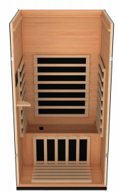
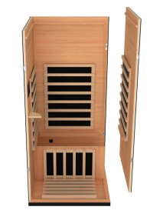

<8> INSTALLING THE BENCH
Install the bench by sliding it onto the horizontal bench support rails located on the side panels.
1. Slide the bench fully into position along the support rails.
2. Push the bench inward until it is flush against the right side panel and securely seated.

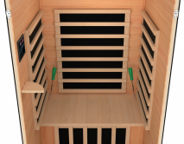
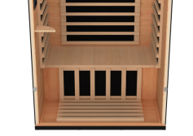

<9> CONNECTING THE FRONT PANEL TO SIDE PANELS

Align the front panel with the interior latches on both side panels.
1. Engage the latches to secure the front panel to the left and right side panels.
2. Handle the glass door carefully during installation to prevent damage.

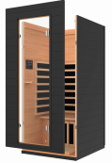
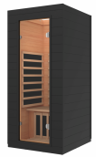

<10>PLACING ROOF PANEL

Carefully lower the roof panel onto the assembled wall panels.
1. Gently position the roof panel on top of the assembled panels.
• Once all four corners are aligned, press down gently at the outside corners until the roof panel fits snugly over the walls.
2. Ensure no cables are pinched between the roof panel and the wall panels.
3. Route the heater wires through the designated opening in the roof panel.
4. Secure the roof panel using the provided 4 × 40 mm screws.
• Tighten screws evenly to ensure the roof panel is stable and properly seated.

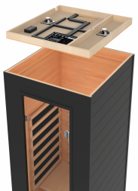

<11> THE MAIN POWER CONNECTION ON THE ROOF PANEL

Before proceeding, confirm the sauna is not connected to a power source.
1. Connect all heater wires by matching the labeled connectors.
• Ensure each connector is fully seated and locked in place.
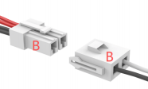
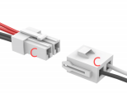
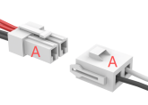

2. Connect the control panel cable labeled CTRL to the corresponding control port.

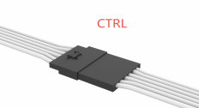
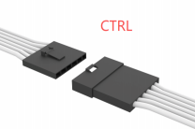

3. Verify that all electrical connections are secure before continuing.

<12>INSTALLING THE ROOF COVER

Place the roof cover on top of the roof panel.
• Align the roof cover with the pre-drilled holes on the roof panel.
• Secure the roof cover using the provided 3 × 14 mm screws.
• Tighten the screws evenly to ensure the cover is properly seated.
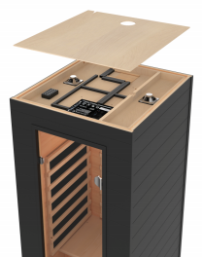

<13> INSTALLING DOOR HANDLE
Install the door handle on the glass door according to the orientation shown.
• Attach the interior and exterior handle components through the pre-drilled holes.
• Tighten the hardware securely, but do not overtighten, as this may damage the glass.

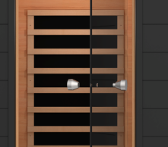
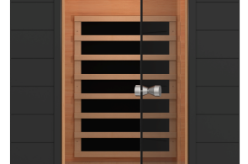

<14> POWERING ON YOUR SAUNA

After completing all assembly steps:
1. Plug the main power cord directly into a properly grounded wall outlet.
2. Turn on the sauna using the control panel.
3. Verify that the control panel, lighting, and heating elements power on correctly.

Before your first session, review the Operating Instructions and Safety Information sections of this manual.

Control Panel Operating Instructions

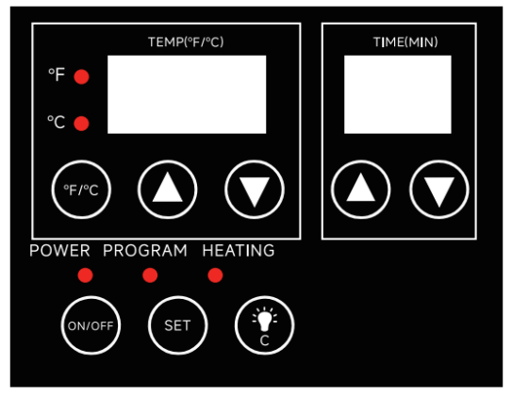

1. Press the  button to turn the sauna on and enter standby mode.

2. Set the desired temperature using buttons.
3. Set the time to desired length using buttons.

4. Press button a second time to activate the heaters.

5. When time reaches 00, all the heaters will automatically shut off.

6. Press and hold to switch the sauna off.


7. Press to turn on/turn off the interior color light. You can change the
color of the light by pressing this bottom.

8. Preset Operation
• Press the SET button once to enter preset mode.
• Use the ▲ / ▼ arrows to set the time at which you want the sauna to turn on automatically.
• Temperature ▲ / ▼ buttons adjust the hour
• Time ▲ / ▼ buttons adjust the minutes
• Preset time range: 00:00 – 23:59

9. Using Bluetooth Audio
A. Turn on the sauna. The internal Bluetooth device will become discoverable automatically.

B. On your mobile device:
- Enable Bluetooth
- Select Add New Device or Bluetooth Devices
- Choose the device named “IRSAUNA”
- Confirm the connection

Once connected, audio will play through the sauna’s built-in speakers.

10. Temperature Range
• Under ideal conditions, the sauna can reach a maximum temperature of 149°F (65°C).
• Under typical indoor ambient conditions (approximately 77°F / 25°C), maximum operating temperature may range between 140°F and 149°F (60°C–65°C).

Actual temperature performance may vary depending on room temperature, ventilation, and installation conditions.

Recommendations for Operation

- Set Temperature and Time
Use the control panel to set your desired session temperature and duration.
- Suggested starting temperature range: 100°F–130°F (37°C–55°C)
- Adjust settings based on personal comfort and tolerance.

- Warm-Up Time
Allow approximately 10–15 minutes for the sauna to warm up before entering.

- Session Duration
Typical session duration is 30–45 minutes.
- Shorter sessions are recommended for first-time users.
- Always end the session if you feel uncomfortable.

- Temperature Control
The heating system automatically maintains the selected temperature during operation.

- Ventilation
The ceiling vent may be opened at any time to improve air circulation and personal comfort.

- Hydration
Drink water before, during, and after use to help maintain normal hydration levels.

- Before and After Use
- If showering before use, dry off completely before entering the sauna to prevent moisture damage to the wood.
- Showering after a session may help rinse perspiration from the body.

- Use of Towels
Place a towel on the bench and floor during use to absorb moisture and help keep the sauna clean.
- Keep an additional towel available to wipe away excess perspiration as needed.

- Natural Wood Aroma
The interior is made from natural wood, which may produce a noticeable aroma when new.
- If the scent is strong during initial use, gently wipe the wood with a damp cloth to reduce the odor.

Recommendations for Use

The following guidelines are intended to help you use your sauna comfortably and responsibly. Always listen to your body and adjust use based on personal comfort.

a) Temperature Adjustment During Use
To adjust comfort during a session, you may open the roof vent or partially open the door to regulate airflow.

b) Cooling as Needed
If additional cooling is needed, open the door until the temperature feels comfortable.

c) Hydration
Drink fluids before, during, and after sauna use to help maintain normal hydration.

d) Showering Before Use
Some users prefer to shower before a sauna session. If you do so, dry off completely before entering to prevent excess moisture from contacting the wood.

e) Hair Care (Optional)
If desired, you may cover your hair with a towel during use. Rinse hair thoroughly after the session if any products were used.

f) Use of Towels
Use one or more towels for comfort and cleanliness:
• Sit on a folded towel for cushioning
• Place a towel on the floor to absorb moisture
• Keep an additional towel available to wipe away perspiration as needed

g) Personal Comfort
Wipe away perspiration during use as needed to maintain comfort.

h) Movement and Stretching
Light stretching or gentle movement may be performed during a session if comfortable. Avoid sudden movements.

i) Lotions and Oils
Avoid applying lotions or oils to the body or face before or during sauna use, as these may affect the skin’s natural response to heat.

j) Eating Before Use
Avoid heavy meals immediately before a session. Many users find sauna use more comfortable when they have not eaten recently.

k) Post-Session Cooling
After a session, allow your body to cool gradually. Sitting with the door partially open for a few minutes before showering may feel more comfortable for some users.

l) Showering After Use
Once you feel comfortable, a warm or cool shower may be taken to rinse perspiration from the body.

m) Electronic Devices
If using personal electronic devices (such as phones or audio players) inside the sauna:
• Limit usage time
• Remove the device immediately if it becomes warm
• Follow the device manufacturer’s temperature guidelines

Safety

Read all safety instructions before installing or using this sauna. Failure to follow these instructions may result in injury, electrical shock, fire, or damage to the product.

If you are unsure whether sauna use is appropriate for you, consult a qualified healthcare professional before use. If you feel light-headed, dizzy, nauseated, or uncomfortable at any time during a session, exit the sauna immediately.

1. This sauna has been manufactured in accordance with applicable safety standards. However, improper installation or use may result in hazards. Always follow the instructions and warnings provided in this manual.

2. When installing and using this electrical equipment, basic safety precautions must always be followed.

3. Before turning on the sauna, ensure that no objects are placed on or against the heating elements.

4. Burn Hazard:
The infrared heating panels become hot during operation.
• Do not touch the heating elements while the sauna is operating.
• Allow the sauna to cool completely before cleaning or servicing.

5. This sauna is not intended for use by children under 8 years of age.

6. Children 8 years of age and older, and individuals with limited physical, sensory, or mental capabilities, or lack of experience or knowledge, may use the sauna only under continuous supervision and after receiving proper instruction on safe use.

7. Children must not play in or around the sauna.

8. Children under 14 years of age may clean the sauna only when supervised.

9. Do not use the sauna immediately after strenuous exercise. Allow at least 30 minutes for the body to cool down before entering.

10. Overheating Risk:
Prolonged exposure to high temperatures may cause overheating. Symptoms may include dizziness, weakness, nausea, drowsiness, or fainting.
• Always limit session duration based on personal comfort.
• Exit the sauna immediately if any discomfort occurs.

11. Pregnant or possibly pregnant individuals should consult a healthcare professional before using the sauna, as elevated temperatures may pose risks during pregnancy.

12. Do not use the sauna while under the influence of alcohol, drugs, or medications that may impair alertness or affect heart rate, blood pressure, or circulation.
13. Individuals with medical conditions such as heart disease, high or low blood pressure, circulatory conditions, diabetes, or other chronic conditions should consult a healthcare professional before use.

14. If you intend to use the sauna for any medical or therapeutic purpose, consult a qualified healthcare professional prior to use. This sauna is not a medical device.

15. Never sleep inside the sauna while it is in operation.

16. Do not use cleaning agents on the interior surfaces of the sauna unless specifically recommended in this manual.

17. Do not place, stack, or store objects on top of or inside the sauna.

18. If the power supply cord becomes damaged, it must be replaced only by the manufacturer, an authorized service provider, or a similarly qualified technician to avoid risk of injury or hazard.

19. Do not use the sauna during an electrical storm due to the potential risk of electrical shock.

20. For added protection during thunderstorms, or when the sauna will be unused for extended
periods, unplug the power cord from the wall outlet.

21. Do not alter or tamper with any electrical connections. Doing so will void the manufacturer’s warranty and may create a safety hazard.

22. Always dry your hands before operating electrical controls.
• Never unplug the power cord or adjust controls with wet hands or while standing barefoot on a wet surface.

23. Do not attempt repairs without first consulting the manufacturer or authorized service provider. Unauthorized repairs will void the warranty.

24. Route the power supply cord so it is not likely to be walked on, pinched, or damaged by furniture or other objects.

25. Do not overload wall outlets or extension cords, as this may result in fire or electrical shock.

26. Always disconnect the sauna from the power source before cleaning or servicing.

27. Do not remove power supply covers. There are no user-serviceable parts inside.

28. If you feel uncomfortable or overheated during a session, lower the temperature, open the door, or exit the sauna immediately.

Important Safeguards For Your Sauna

1. READ INSTRUCTIONS -- All the safety and operating instructions should be read before the sauna is installed and operated.
2. RETAIN INSTRUCTIONS -- The safety and operating instructions should be retained for future reference.
3. FOLLOW INSTRUCTIONS -- All operating and usage instructions should be followed at all times.
4. CLEANING -- Unplug the sauna from the wall outlet before cleaning DO NOT use liquid cleaners or aerosol cleansers inside the sauna. Use a damp cloth for cleaning.
5. ATTACHMENTS-- Do not use any attachments that are not recommended by the manufacturer, may be hazardous.
6. WATER OR MOISTURE—DO NOT use your sauna near water, e.g. near a bathtub, in a wet basement, or near a swimming pool and the like.
7. POWER-CORD PROTECTION-- Power supply cord should be routed so it is not likely to be walked on or pinched by items placed upon or against it.
8. LIGHTING-- For added protection for your sauna during a lightning storm, or when it is left unattended and unused for long time, unplug it from the wall outlet.
9. OVERLOADING-- Do not overload wall outlet and extension cord as this can result in a risk of fire or electric shock.
10. SERVICING-- Always unplug your sauna from the wall outlet before servicing.
11. REPLACEMENT PARTS--When replacement parts are required, be sure it is specified by the manufacturer or have the same characteristics as the original parts. Unauthorized substitutes may result in fire, electric shock or other hazards.
12. SAFETY CHECK--Upon completion of any service or repairs to your sauna, ask the service technician to perform safety checks and determine that your sauna is in proper operation condition.

Cleaning and Maintenance

1. Natural Wood Characteristics
Your sauna is constructed from natural wood. Variations in color, grain, knots, minor cracks, or natural oil markings are normal characteristics of wood and reflect its natural appearance. These variations are not considered defects.

2. Initial Cleaning
Before using the sauna for the first time, wipe the interior surfaces with a clean, damp cloth.

3. Natural Wood Aroma
The interior wood may produce a natural aroma, especially during the first few months of use. If the scent is noticeable, gently wipe the interior wood surfaces with a damp cloth to help reduce the aroma.

4. Exterior Cleaning
Clean the exterior surfaces using a soft cloth. A furniture-safe polish may be used on exterior wood surfaces only.

5. Use of Towels
To help absorb moisture and maintain cleanliness, place a soft towel on the bench and floor during sauna use.

6. Minor Surface Marks
Light scratches or surface marks may be reduced by gently sanding the affected area with fine-grit sandpaper, sanding in the direction of the wood grain.

7. Cleaning Restrictions
Do not clean the sauna using steam cleaners, high-pressure washers, or by splashing water on any part of the unit.

8. Wood Texture Changes
In humid conditions, the wood surface may feel slightly rough. If this occurs, lightly smooth the area using fine-grit sandpaper or a non-abrasive sanding sponge, always following the direction of the grain.

9. Seasonal Wood Movement
Mahogany or hemlock wood may experience minor cracking, warping, or natural oil markings due to seasonal changes in humidity. This is a natural characteristic of solid wood and does not indicate a material defect.

Troubleshooting

NO | Common faults | Cause Analysis | Treatment
1 | Sauna is not working | No power at the outlet power | Check whether the power outlet is functioning correctly. If it is not, examine the main circuit breaker or the electrical wiring associated with the outlet.
1 | Sauna is not working | The sauna control system does not work | Please contact the after-sales team to replace the control system
2  3 | No response from control panel buttons when operated | Loose or faulty connection between control panel and main control box. | Ensure the connection cable is fully reinserted and firmly secured.
2  3 | No response from control panel buttons when operated | Electronic components of the control panel are damaged. | Please contact the after-sales team to replace the control panel
2  3 | The far-infrared heater is not  heating. | The wiring connection between the heater and the output terminal of the main control box is faulty or loose. | Step 1: Disconnect the power supply. Step 2: Reinsert the connection wires and ensure they are firmly secured.
2  3 | The far-infrared heater is not  heating. | Far-infrared heater is damaged | Step 1. Doublecheck each heater individually to verify that it is working normally.  Step 2. To determine if a heater is working:  - Visually check whether the heater is emitting heat, or  - Use a thermal imaging camera to detect heat output.  3. If any far-infrared heater is not heating, please contact after-sales service to arrange a replacement.
2  3 | The far-infrared heater is not  heating. | The main control box is damaged and there is no voltage output. | Please contact the after-sales team to replace the main control box
2  3 | The far-infrared heater is not  heating. | Set the temperature lower than the ambient temperature | Adjust the temperature to the highest setting.
2  3 | The far-infrared heater is not  heating. | The control panel buttons do not activate the heating function | Step 1. Ensure the control panel is in standby mode.  Step 2. Press the power button again.  Step 3. The heating indicator light will turn on, indicating that the heating function has been activated.
4 | Abnormal temperature regulation in sauna room | The far-infrared heater in a certain area is not generating heat. | Reconnect and securely fasten the heater wiring in the affected area. If the far-infrared heater is damaged. If the far-infrared heater is damaged  ,contact after-sales for replacement.
4 | Abnormal temperature regulation in sauna room | Temperature setting on the control panel is incorrect | Ensure the set temperature is higher than the surrounding environment temperature.
4 | Abnormal temperature regulation in sauna room | The temperature sensor may be loose or broken | Ensure the temperature sensor is properly reconnected and firmly secured.
5 | The lights inside the sauna  room are not working. | The wiring or terminal connection between the  lighting fixture and the main control box is faulty or loose. | Step 1: Check the wiring connections of the lights.  Step 2: Ensure the wires are properly reinserted and firmly secured.
5 | The lights inside the sauna  room are not working. | Color lighting is damaged. | If the color lighting is damaged , please contact after-sales for replacement
6 | Speaker Problems:  No sound or poor sound | The soldered wiring of the top cover speaker is faulty, or the speaker is damaged. | If the speaker is damaged , please contact after-sales for replacement
6 | Speaker Problems:  No sound or poor sound | The internal wiring inside the Bluetooth box is loose or has a faulty connection. | Step 1: Open the Bluetooth box cover;  Step 2: Reconnect and securely fasten the speaker wires.
6 | Speaker Problems:  No sound or poor sound | The internal circuit board of the Bluetooth box is faulty and not working. | If the Bluetooth box circuit board is damaged , please contact after-sales for replacement
7 | Special burning smell | The sauna room wiring was faulty, causing some components in the electrical system to burn out. | Be sure to disconnect the power supply immediately and contact after- sales service.

Disclaimers

The manufacturer shall not be liable for any loss or damage resulting from the use or misuse of this product. This includes, but is not limited to, incidental or consequential damages, to the extent permitted by law.

Under no circumstances shall the manufacturer or its representatives be liable for injury to persons or damage to property arising from improper installation, improper use, or failure to follow the instructions and safety information contained in this manual.

Any implied warranties, including implied warranties of merchantability or fitness for a particular purpose, are limited in duration to the period of the applicable written warranty, to the extent permitted by law.

Product specifications are subject to change without notice or obligation.

Legal Remedies

This limited warranty gives the original purchaser specific legal rights. You may also have other rights, which vary from state to state.
Some states do not allow limitations on the duration of implied warranties or the exclusion or limitation of incidental or consequential damages. As a result, the above limitations or exclusions may not apply to you.

Serial Number

The product serial number is located on the exterior of the back panel of the sauna.
Please record the serial number and retain it for your records. The serial number is required when contacting customer support for service, warranty claims, or replacement parts.

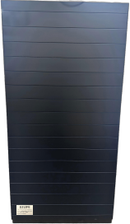

One-Year Limited Warranty

The manufacturer warrants this product against defects in materials and workmanship on functional parts only, for a period of 1 year from the original date of purchase. Your sales receipt showing the date of purchase of the product is your proof of purchase. Keep it in a safe place for future reference. This warranty is subject to personal use only, commercial or rental applications will not be covered. Continuous operating exceeding 3,000 hours will also void the warranty.

This product is made with the highest quality materials and is warranted to be free from defects in materials and workmanship at the time of purchase. This limited warranty applies to products manufactured or distributed by the manufacturer, are delivered in the continental United States or Canada and extends to the original purchaser, or gift recipient. This warranty becomes valid at the time of purchase and terminates either by the specified time frame listed above and/or owner transfer. Any refunds or monetary compensations must be claimed through the place of purchase (retailer), and not through the manufacturer. Any extended warranties (warranties that cover above and beyond this manufacturer warranty) that are sold through a retailer or third party, are not directly correlated with this products’ limited warranty, and may be redirected to said retailer or third party for coverage.

This warranty extends through the manufacturer of the product, and covers functional parts only. Cosmetics are not covered, unless unequivocally determined it is a workmanship defect. Shipping damage should be addressed with the shipping company, retailer, or place of purchase, not the manufacturer unless the manufacturer was the direct shipper.

The manufacturer’s sole obligation under this warranty shall be limited to furnishing the original purchaser replacement parts for units deemed repairable by the supplier’s warranty department. The purchaser is responsible for insuring any parts shipped or returned, if desired. The purchaser is responsible to prepay any shipping charges (both ways) including, but not limited to taxes and duties. All exchanged parts and products replaced under this warranty will become the property of manufacturer. The manufacturer reserves the right to change manufacturers of replacement parts or products for use, in order to cover any existing warranty.
The purchaser may be asked to provide the supplier with proof of purchase documents (including the date of purchase) if requested. Any evidence of alteration, erasing, or forgery of proof of purchase documents will be just cause to VOID this limited warranty. Products, in which the serial number has been defaced or removed are not eligible for warranty coverage.

This warranty does not apply if the unit has been subject to negligence, fabrication, misuse, abuse, or repairs, alteration by non-manufacturer authorized personnel, inappropriate installations, or any case beyond the control of the manufacturer. Examples of warranty invalidation may also include, but are not limited to:
• Use of lacquer or paints in (and around) the product.
• Product placed on non-approved surfaces
• Electrical requirement deficiencies
• Use of extension cords/timers/surge protectors/GFCI
• Outdoor applications
• Normal wear/tear/weathering
• Pet/consumer accidents
• Purchases from dealers unauthorized by the manufacturer (Authorization in writing)

The manufacturer shall not be liable for any loss due to use (or misuse) of the product or other incidental or consequential costs, expense or damages without irrefutable foundations. Under no circumstances shall the manufacturer or any of its representatives be held liable for injury to any person or damage to any property, however arising. Any implied warranty shall have duration equal of the applicable warranty stated above. Specifications are subject to change without notice or obligation.
This limited warranty gives the original purchaser specific legal rights. Other rights may vary from state to state.

